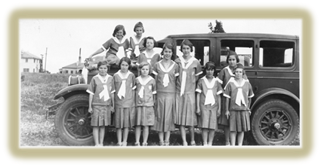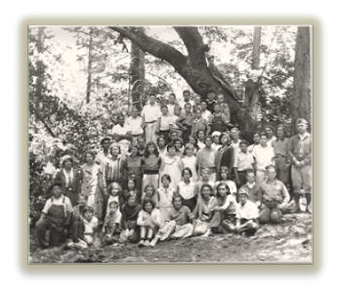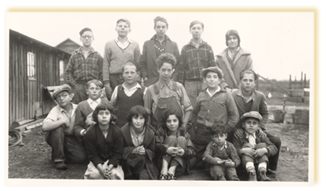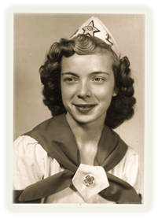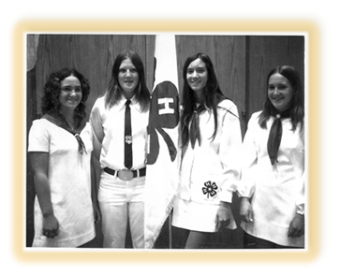
Share Your California 4-H Story!

As part of California’s Centennial Celebration, we want to hear your 4-H story!
Tell us a little about your experiences in 4-H and how they impacted your life. Here are some ideas that might help you get started! Do any of these story ideas spark your memory? Pick one, and fill in the blanks (or do more than one if you like). You are welcome to use a separate sheet of paper or type your response(s) into the body of your email. Then email to solanocounty4h@gmail.com.

STORY IDEA 1 Find a favorite photo from your 4-H days and tell what you remember about the day it was taken.
(Please attach the photo to the email)
• About what year was it, and where was it taken?
• How old were you and what 4-H club were you a member of?
• What were you doing in the photo?
• How did you feel when the picture was taken? (Tell why)
• Did this moment have a lasting impact on you? (Tell why)

STORY IDEA 2 Tell about a personal triumph you experienced in 4-H!
• How old were you and what 4-H club were you a member of?
• What was the triumph?
• How did you feel? (Tell why)
• Did the experience have a lasting impact on you? (Tell how it affected you)

STORY IDEA 3 What was the greatest challenge you mastered in 4-H?
• How old were you and what 4-H club were you a member of?
• Tell about the challenge. What made it challenging?
• How did you overcome it and what made it rewarding?
• Did the experience have a lasting impact on you? (Tell how it affected you)

STORY IDEA 4 What was your favorite project?
• What 4-H club were you a member of?
• Tell about the project. What made it special?
• Did the experience have a lasting impact on you? (Tell how it affected you)

STORY IDEA 5 Did something turn out in a way that you never expected?
• Tell a little about the experience (What happened? Where were you? How old were you?)
• What was surprising about it?
• What was the outcome?

STORY IDEA 6 Who made a difference in your 4-H experience?
• What caring adult made your 4-H experience even better?
• Tell how they made a difference.
• Which of their actions or statements will you always remember?

STORY IDEA 7 Do you think 4-H changed you as a person?
• What club were you a member of?
• Tell what 4-H experiences impacted your life
• How are you different as a result?

