**Walnut Hedgerow Pruning and Training Trial: 2010**

Carolyn DeBuse, John Edstrom, Janine Hasey, and Bruce Lampinen

**OBJECTIVE**

The objective of this trial is to consider different training styles in the early years for hedgerow planted Chandler walnuts. This trial also evaluates two new varieties, Gillet and Forde, and compares them to the older varieties of Tulare and Chandler for their ability to be trained in a hedgerow planting. A secondary aspect of this experiment is to see if reducing vigor with deficit irrigation in the 3-6th year would postpone the need for early hedging and help maintain a smaller sized tree without negative impacts on yield.

**Procedure**

The trial is located within the Nickels Soil Lab hedgerow planting of Chandler that also contains three rows of other varieties; one row each of Tulare, Forde and Gillet. The trees were planted in March 2008 on a one foot berm, at a spacing of 15 ft. x 22 ft. (132 trees per acre). The trees were nursery budded on Paradox rootstock. The orchard is irrigated with double line drip with inline emitters spaced 22 inches apart.

Training systems for this trial began at the end of the first growing season. Four training systems were applied in a randomized block experimental design containing 6 replicated plots of each treatment. Each plot is three rows across with 5 trees in each row. Data was collected from the three interior trees. The training systems were renamed and refined before the second year pruning to create more distinction between treatments. The training systems include:

1. **Heavily pruned hedgerow** training (T1). Heading the one year old trees at a height of 6 feet. Second year, select and head a central leader by 1/3 of height. Select 4-6 primary scaffolds and head each by 1/3 their height. Heights of scaffolds are below the height of the central leader. All unselected branches were removed if they were large and able to compete with chosen scaffolds. Forked branches are reduced to a single branch and branches below 3-4 feet are removed. All remaining branches and fruit wood are tipped or removed. Third year, head all main scaffolds and leader. Fourth year, minimal pruning, head leader and main scaffolds if needed.

GREEN

1. **Minimally pruned hedgerow/low vigor** training (T2). Follow minimal hedgerow training (T 3) with restricted irrigation from year 3 on to create lower vigor.

Salmon (Pink)

1. **Minimally pruned hedgerow** training (T3). Recommended pruning style that benefits early cropping and faster canopy development. First year, head main scaffold at 6 feet. Second year, select central leader and head by 1/3 of height. Select 4-6 primary scaffolds and head each below the height of the central leader. The heading cut should remove 1/4 to 1/3 of the length of the previous season growth. Forked branches on selected scaffolds should be reduced to a single branch. Leave remaining unselected branches and small caliper fruit wood left unpruned and unheaded to create early fruiting wood. Third year, head central leader and main scaffolds. Fourth year, minimal pruning, head leader and main scaffolds if needed.

Blue

Yellow

1. **No heading/pruning hedgerow** training (T4). First year, remove lower branches and select one main trunk. No heading of trunk. Following years, no pruning unless lower branches need to be removed for reasons of safety or ease of maintenance and harvest.

The variety training trial was restricted due to the fact that only one row of trees were planted of Tulare, Forde and Gillet. Within each of these varieties, 7 plots of 5 trees were randomly chosen for one of three training treatments: 2 plots of heavily pruned (T1), 2 plots minimally pruned (T3) and 3 plots no pruning (T4). Minimal/low vigor training (T2) was not included in the variety trial.

Table 1. Average circumference of the tree in each treatment in March 2009, December 2009 and November 2010.

|  |  |  |  |  |
| --- | --- | --- | --- | --- |
| **Variety** | **Treatment** | **Average circumference at 2 feet above ground March 2009 (cm)** | **Average circumference**  **at 2 feet above ground Dec. 2009 (cm)** | **Average circumference at 2 feet above ground Nov. 2010 (cm)** |
| **Chandler** | Heavily pruned (1) | 8.25 a | 20.4 a | 27.9 b |
|  | Minimal/low vigor (2) | 8.25 a | 21.7 a | 32.0 a |
|  | Minimally pruned (3) | 7.89 a | 20.3 a | 29.7 ab |
|  | No heading/pruning (4) | 8.17 a | 20.9 a | 30.4 a |
| **Tulare** | Heavily pruned (1) | 8.56 a | 22.3 a | 32.4 a |
|  | Minimally pruned (3) | 9.22 a | 21.8 a | 31.5 a |
|  | No heading/pruning (4) | 8.79 a | 19.3 a | 27.7 a |
| **Forde** | Heavily pruned (1) | 9.28 a | 23.7 a | 33.1 a |
|  | Minimally pruned (3) | 8.96 a | 23.7 a | 32.3 a |
|  | No heading/pruning (4) | 9.43 a | 23.3 a | 32.1 a |
| **Gillet** | Heavily pruned (1) | 9.20 a | 23.3 a | 34.3 a |
|  | Minimally pruned (3) | 9.03 a | 23.8 a | 37.4 a |
|  | No heading/ pruning (4) | 8.41 a | 19.8 b | 30.5 a |

Table 2. The average height of tree in March 2009, December 2009 and in November 2010.

|  |  |  |  |  |
| --- | --- | --- | --- | --- |
| **Variety** | **Treatment** | **3/23/2009**  **Average Height (cm)** | **12/4/2009**  **Average Height (cm)** | **11/18/10**  **Average Height (cm)** |
| **Chandler** | Heavily pruned (1) | 192.2 b | 389.4 c | 468.2 c |
|  | Minimal/low vigor (2) | 197.2 b | 421.1 b | 525.2 a |
|  | Minimally pruned (3) | 190.6 b | 389.6 c | 510.9 ab |
|  | No heading/pruning (4) | 280.4 a | 481.6 a | 480.8 bc |
| **Tulare** | Heavily pruned (1) | 204.8 b | 460.8 a | 548.2 a |
|  | Minimally pruned (3) | 205.7 b | 489.2 a | 533.0 a |
|  | No heading/pruning (4) | 326.3 a | 513.9 a | 503.9 a |
| **Forde** | Heavily pruned (1) | 191.0 b | 466.3 b | 561.5 a |
|  | Minimally pruned (3) | 192.5 b | 452.3 b | 576.8 a |
|  | No heading/pruning (4) | 288.7 a | 529.3 a | 555.9 a |
| **Gillet** | Heavily pruned (1) | 191.3 b | 490.3 a | 569.3 a |
|  | Minimally pruned (3) | 204.7 b | 492.8 a | 570.3 a |
|  | No heading/pruning (4) | 294.1 a | 425.2 b* | 458.2* b |

*Shorter height in Gillet likely due to extensive breakage early in 2009 season.

Table 3. Average canopy PAR interception measured with Mule mobile platform on 7/9/10.

|  |  |  |  |  |
| --- | --- | --- | --- | --- |
| **Variety** | **Treatment** | **PAR interception (%)** | **Yield (tons/acre)** | **Yield per unit PAR intercepted** |
| **Chandler** | Heavily pruned (1) | 17.4 b | 0.14 c | 0.008 c |
|  | Minimal/low vigor (2) | 22.4 ab | 0.37 b | 0.016 b |
|  | Minimally pruned (3) | 22.3 ab | 0.33 b | 0.014 b |
|  | No heading/pruning (4) | 24.1 a | 0.73 a | 0.030 a |
| **Tulare** | Heavily pruned (1) | 19.9 a | 0.27 a | 0.014 c |
|  | Minimally pruned (3) | 19.2 a | 0.47 a | 0.023 b |
|  | No heading/pruning (4) | 19.4 a | 0.63 a | 0.033 a |
| **Forde** | Heavily pruned (1) | 23.4 a | 0.26 b | 0.012 b |
|  | Minimally pruned (3) | 21.9 a | 0.55 ab | 0.024 b |
|  | No heading/pruning (4) | 23.2 a | 0.92 a | 0.039 a |
| **Gillet** | Heavily pruned (1) | 19.5 a | 0.23 c | 0.013 c |
|  | Minimally pruned (3) | 18.0 a | 0.38 b | 0.020 b |
|  | No heading/ pruning (4) | 16.0 a | 0.52 a | 0.032 a |

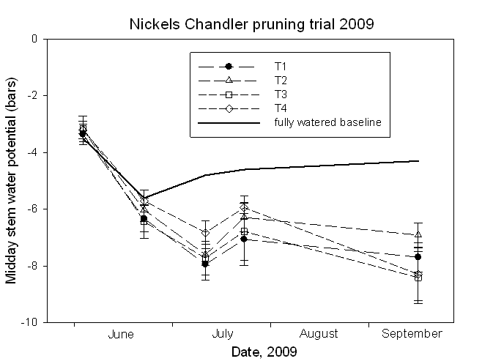

Figure 4. Midday stem water potential (bars) for the four Chandler pruning treatments throughout the 2009 season.

Figure 5. Midday stem water potential (bars) for the different varieties and pruning treatments for the 2010 season.

