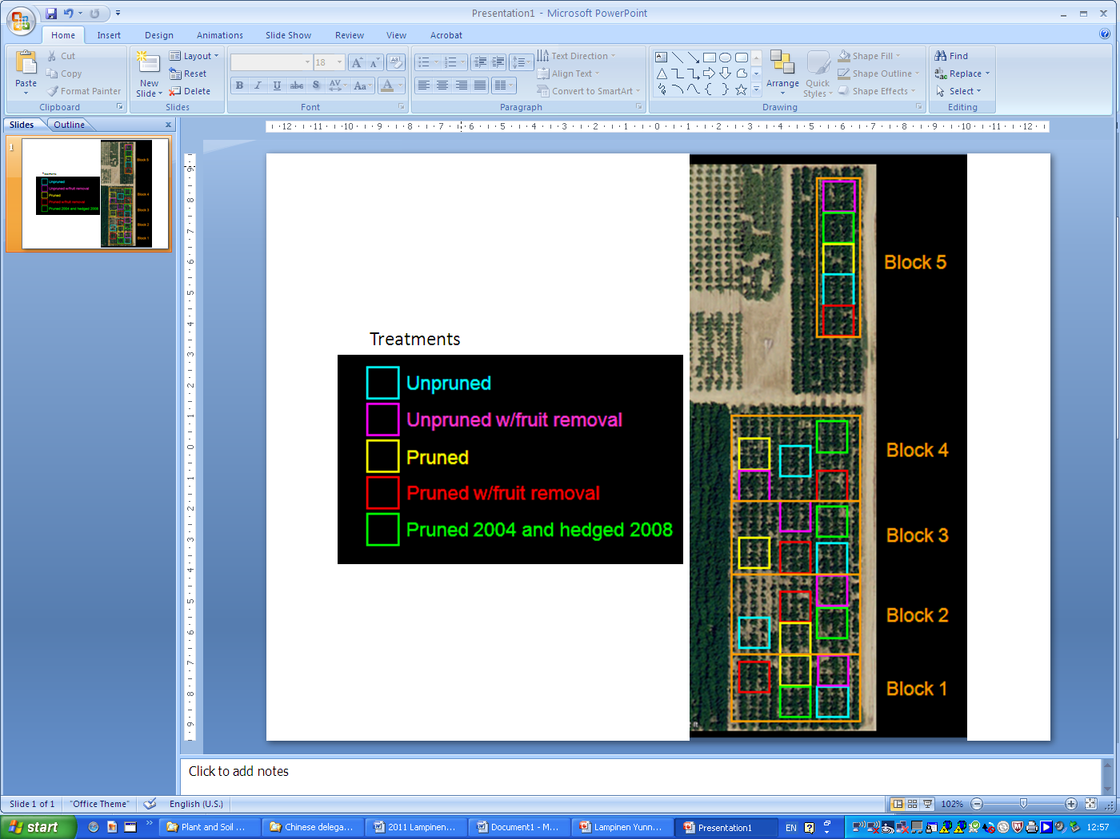**Nickels Howard Pruning trial-** Initiated in spring of 2004 (3rd leaf) after scaffold selection had taken place.





Fig. 2. Cumulative yield (tons per acre) by year and treatment.





