**Walnut Hedgerow Pruning and Training Trial: 2010**

Carolyn DeBuse, John Edstrom, Janine Hasey, and Bruce Lampinen

Abstract

Hedgerow walnut orchards have been studied since the 1970s as a high density system to reduce pruning costs and to benefit early production. At present, the common pruning methods are similar to the methods used to establish conventionally spaced orchards with some differences in height of the first scaffold selected and the amount of wood removed in the early years. This trial looks at ways to improve this pruning method to gain a better tree structure, improve the amount of fruit wood, decrease wind damage and potentially reduce the need for early hedging of the orchard. Four hedgerow training systems were implemented starting in 2009 after the first season of growth; heavily pruned, minimally pruned, minimally pruned with restricted irrigation and unpruned. Tree growth characteristics of diameter, height, canopy size (light interception), and yield were measured in 2010. Plant water status was measured using midday stem water potential throughout the growing season. Results in 2010 showed that the minimally pruned treatment, was significantly taller than the unpruned and the heavily pruned. The heavily pruned treatment was significantly shorter than the minimally pruned treatments but not different from the unpruned. In the varietal comparison, Gillet unpruned was significantly shorter than both of the other treatments within Gillet and compared to the other varieties. This may have been due to extensive breakage early in 2009 season. Comparison of yield and canopy light interception between treatments and varieties showed that in Chandler unpruned the yield and yield per unit of canopy light intercepted (PAR) was significantly higher than all other treatments. The actual canopy size measured by the PAR interception on July 9, 2010 of the unpruned trees was not significantly different from the two minimally pruned treatments but larger than the heavily pruned treatment. The water status of the unpruned treatment showed the highest stress in the spring between the treatments though was not significantly different. Progressively from August until the end of the season the unpruned treatment showed the least amount of stress with the midday stem water potential being at or above the baseline. By the end of the season the midday stem water potential of the unpruned treatment was significantly higher (less stressed) than all other treatments.

**OBJECTIVE**

The objective of this trial is to consider different training styles in the early years for hedgerow planted Chandler walnuts. This trial also evaluates two new varieties, Gillet and Forde, and compares them to the older varieties of Tulare and Chandler for their ability to be trained in a hedgerow planting. A secondary aspect of this experiment is to see if reducing vigor with deficit irrigation in the 3-6th year would postpone the need for early hedging and help maintain a smaller sized tree without negative impacts on yield.

**Procedure**

The trial is located within the Nickels Soil Lab hedgerow planting of Chandler that also contains three rows of other varieties; one row each of Tulare, Forde and Gillet. The trees were planted in March 2008 on a one foot berm, at a spacing of 15 ft. x 22 ft. (132 trees per acre). The trees were nursery budded on Paradox rootstock. The orchard is irrigated with double line drip with inline emitters spaced 22 inches apart.

Training systems for this trial began at the end of the first growing season. Four training systems were applied in a randomized block experimental design containing 6 replicated plots of each treatment. Each plot is three rows across with 5 trees in each row. Data was collected from the three interior trees. The training systems were renamed and refined before the second year pruning to create more distinction between treatments. The training systems include:

1. **Heavily pruned hedgerow** training (T1). Heading the one year old trees at a height of 6 feet. Second year, select and head a central leader by 1/3 of height. Select 4-6 primary scaffolds and head each by 1/3 their height. Heights of scaffolds are below the height of the central leader. All unselected branches were removed if they were large and able to compete with chosen scaffolds. Forked branches are reduced to a single branch and branches below 3-4 feet are removed. All remaining branches and fruit wood are tipped or removed. Third year, head all main scaffolds and leader. Fourth year, minimal pruning, head leader and main scaffolds if needed.
2. **Minimally pruned hedgerow/low vigor** training (T2). Follow minimal hedgerow training (T 3) with restricted irrigation from year 3 on to create lower vigor.
3. **Minimally pruned hedgerow** training (T3). Recommended pruning style that benefits early cropping and faster canopy development. First year, head main scaffold at 6 feet. Second year, select central leader and head by 1/3 of height. Select 4-6 primary scaffolds and head each below the height of the central leader. The heading cut should remove 1/4 to 1/3 of the length of the previous season growth. Forked branches on selected scaffolds should be reduced to a single branch. Leave remaining unselected branches and small caliper fruit wood left unpruned and unheaded to create early fruiting wood. Third year, head central leader and main scaffolds. Fourth year, minimal pruning, head leader and main scaffolds if needed.
4. **No heading/pruning hedgerow** training (T4). First year, remove lower branches and select one main trunk. No heading of trunk. Following years, no pruning unless lower branches need to be removed for reasons of safety or ease of maintenance and harvest.

The variety training trial was restricted due to the fact that only one row of trees were planted of Tulare, Forde and Gillet. Within each of these varieties, 7 plots of 5 trees were randomly chosen for one of three training treatments: 2 plots of heavily pruned (T1), 2 plots minimally pruned (T3) and 3 plots no pruning (T4). Minimal/low vigor training (T2) was not included in the variety trial.

Data collected in the growing season of 2009 for all varieties included, diameter (mm) at 2 and 6 feet of height in March and again at 2 feet at the end of the season in December, height of main trunk after pruning in March and in December, total number of emerging shoots in May, and number of emerging shoots above 3 feet from the ground in May. Midday stem water potential was measured in June, July, and September on the Chandler variety. Number of shoots per 10 centimeters of main trunk was calculated.

In November 2010, circumference at 2 feet above ground, height of tallest branch, and yield were measured. During the 2010 growing season, midday stem water potential was measured using a pressure chamber approximately every 2 weeks and canopy light interception was measured with a Mule mobile platform. Analysis using ANOVA and Duncan’s multiple range test was performed using SAS (GLM procedure).

**Results and Discussion**

2010 Chandler results show a difference in average circumference, average height, yield and average canopy light interception.

Shown in table one, the heavily pruned treatment has a significantly smaller average circumference than the unpruned and the minimally pruned treatment 2. It was not significantly different from treatment 3 which is the same minimally pruned treatment since deficits will not be imposed until 2011. The average circumferences of the varietal comparison show no significant difference between the treatments. The difference shown last year in the unpruned Gillet circumference is no longer significantly different but was the smallest of the three treatments. This is likely at least partly due to severe wind breakage in 2009 before stakes were extended in unpruned Gillet treatment trees.

Chandler treatment 2, minimally pruned, was significantly taller than the unpruned and the heavily pruned but was not significantly different from the other minimally pruned treatment 3 (Table 2). The heavily pruned treatment was significantly shorter than the minimally pruned treatments but not different from the unpruned. In the varietal comparison, Gillet unpruned was significantly shorter than both of the other treatments within Gillet and compared to the other varieties. This may have been due to extensive breakage early in 2009 season.

Comparison of yield and canopy light interception between treatments and varieties showed that in Chandler unpruned the yield and yield per unit of canopy light intercepted (PAR) was significantly higher than all other treatments (Table 3). The actual canopy size measured by the PAR interception on July 9, 2010 of the unpruned trees was not significantly different from the two minimally pruned treatments but significantly larger than the heavily pruned treatment. These results may be because the unpruned treatment did not put on secondary growth in 2009. The heavily pruned treatment had significantly lower yield and light interception compared to the other treatments and this may be explained by the larger amount of wood that was removed from the tree during pruning. These results were repeated in the varietal comparison where PAR interception was not significantly different between treatments but yield and yield per unit PAR interception was significantly greater in the Forde and Gillet unpruned treatment. Tulare was the only variety that did not show significant differences in yield/acre for the unpruned treatment but did show the same difference as the other varieties when yield per unit PAR interception was calculated.

In 2009, the midday stem water potential of the Chandlers showed no significant differences between treatments but did show a trend through the first half of the season for the unpruned trees to be less stressed (Figure 4). This has been observed in other pruning trials (Lampinen, unpublished). In September, all treatments showed moderate levels of stress.

In 2010, the midday stem water potential of the Chandlers showed a different trend from the year before (Figure 5). The unpruned treatment showed the highest stress in the spring between the treatments though was not significantly different. Progressively from August until the end of the season the unpruned treatment showed the least amount of stress with the midday stem water potential being at or above the baseline. By the end of the season the midday stem water potential of the unpruned treatment was significantly higher (less stressed) than all other treatments.

These results were repeated in the varietal comparison with similar results with the unpruned treatment tending to be more stressed early in the season. However, by late in the season, the unpruned treatment trees were significantly less stressed in all varieties.

Figure 1-3 show a progression of photos taken of the same two trees over the season. The tree on the left is unpruned and the one on the right is a minimally pruned tree.

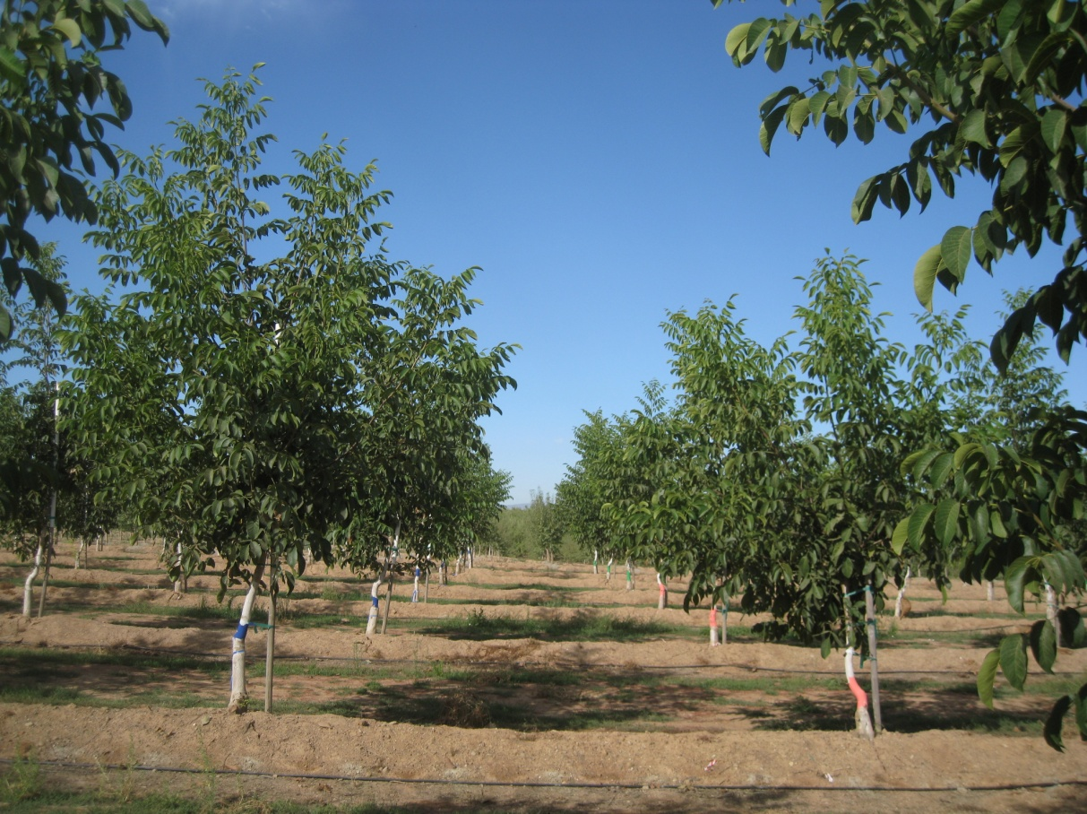

Figure 1. Example of unheaded Chandler tree (on the left) and headed Chandler tree on the right, (photo on Sept. 19, 2009). Unheaded Chandlers averaged 20% taller than headed trees on Sept. 19, 2009.

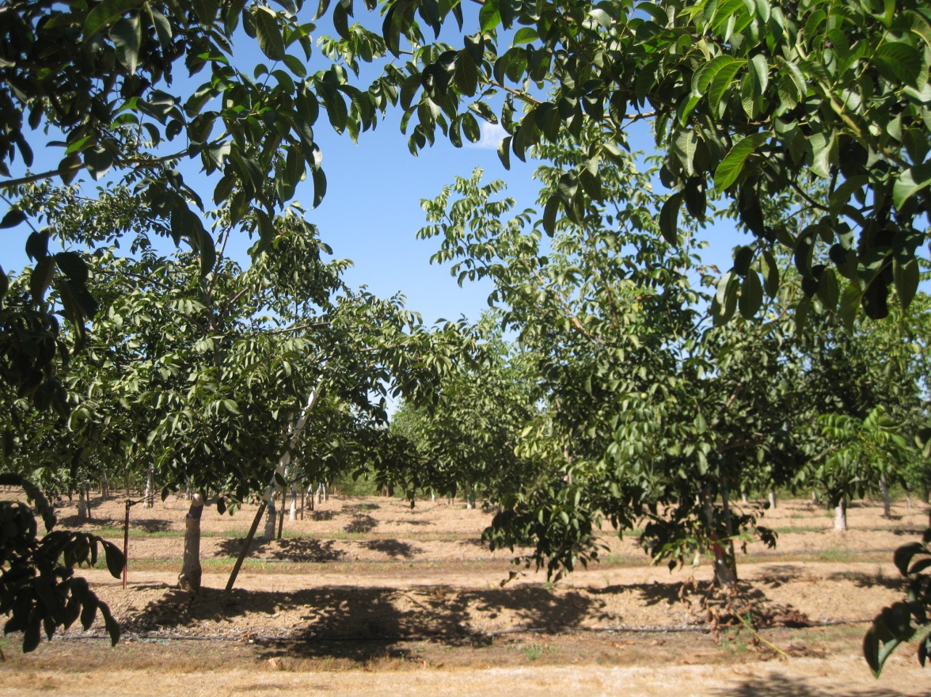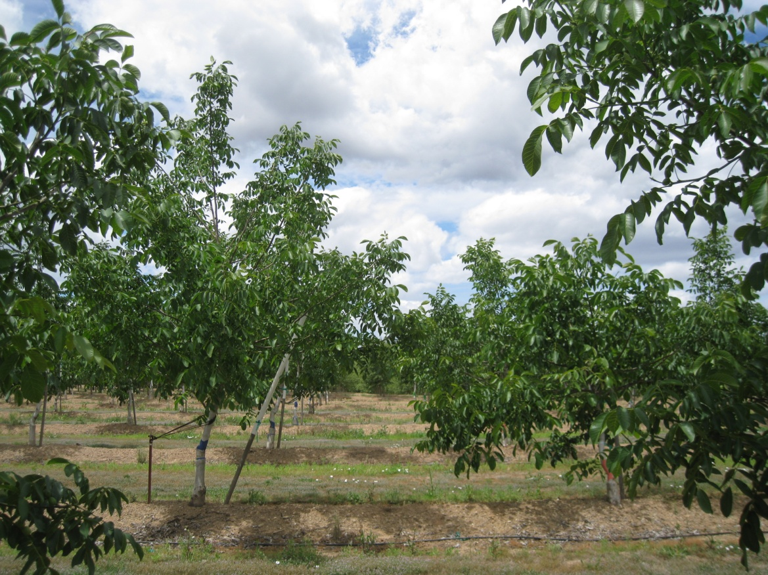

Figure 2. Example of unpruned Chandler tree, on the left, and minimal pruned Chandler tree on the right (photo on June 3, 2010).

Figure 3. Example of unpruned Chandler tree, on the left, and minimal pruned Chandler tree on the right, (photo on Sept. 15 2010).

Table 1. Average circumference of the tree in each treatment in March 2009, December 2009 and November 2010.

|  |  |  |  |  |
| --- | --- | --- | --- | --- |
| **Variety** | **Treatment** | **Average circumference at 2 feet above ground March 2009 (cm)** | **Average circumference**  **at 2 feet above ground Dec. 2009 (cm)** | **Average circumference at 2 feet above ground Nov. 2010 (cm)** |
| **Chandler** | Heavily pruned (1) | 8.25 a | 20.4 a | 27.9 b |
|  | Minimal/low vigor (2) | 8.25 a | 21.7 a | 32.0 a |
|  | Minimally pruned (3) | 7.89 a | 20.3 a | 29.7 ab |
|  | No heading/pruning (4) | 8.17 a | 20.9 a | 30.4 a |
| **Tulare** | Heavily pruned (1) | 8.56 a | 22.3 a | 32.4 a |
|  | Minimally pruned (3) | 9.22 a | 21.8 a | 31.5 a |
|  | No heading/pruning (4) | 8.79 a | 19.3 a | 27.7 a |
| **Forde** | Heavily pruned (1) | 9.28 a | 23.7 a | 33.1 a |
|  | Minimally pruned (3) | 8.96 a | 23.7 a | 32.3 a |
|  | No heading/pruning (4) | 9.43 a | 23.3 a | 32.1 a |
| **Gillet** | Heavily pruned (1) | 9.20 a | 23.3 a | 34.3 a |
|  | Minimally pruned (3) | 9.03 a | 23.8 a | 37.4 a |
|  | No heading/ pruning (4) | 8.41 a | 19.8 b | 30.5 a |

Table 2. The average height of tree in March 2009, December 2009 and in November 2010.

|  |  |  |  |
| --- | --- | --- | --- |
|  |  |  |  |
| **Variety** | **Treatment** | **3/23/2009**  **Average Height (cm)** | **12/4/2009**  **Average Height (cm)** | **11/18/10**  **Average Height (cm)** |
| **Chandler** | Heavily pruned (1) | 192.2 b | 389.4 c | 468.2 c |
|  | Minimal/low vigor (2) | 197.2 b | 421.1 b | 525.2 a |
|  | Minimally pruned (3) | 190.6 b | 389.6 c | 510.9 ab |
|  | No heading/pruning (4) | 280.4 a | 481.6 a | 480.8 bc |
| **Tulare** | Heavily pruned (1) | 204.8 b | 460.8 a | 548.2 a |
|  | Minimally pruned (3) | 205.7 b | 489.2 a | 533.0 a |
|  | No heading/pruning (4) | 326.3 a | 513.9 a | 503.9 a |
| **Forde** | Heavily pruned (1) | 191.0 b | 466.3 b | 561.5 a |
|  | Minimally pruned (3) | 192.5 b | 452.3 b | 576.8 a |
|  | No heading/pruning (4) | 288.7 a | 529.3 a | 555.9 a |
| **Gillet** | Heavily pruned (1) | 191.3 b | 490.3 a | 569.3 a |
|  | Minimally pruned (3) | 204.7 b | 492.8 a | 570.3 a |
|  | No heading/pruning (4) | 294.1 a | 425.2 b* | 458.2* b |

*Shorter height in Gillet likely due to extensive breakage early in 2009 season.

Table 3. Average canopy PAR interception measured with Mule mobile platform on 7/9/10.

|  |  |  |  |  |
| --- | --- | --- | --- | --- |
| **Variety** | **Treatment** | **PAR interception (%)** | **Yield (tons/acre)** | **Yield per unit PAR intercepted** |
| **Chandler** | Heavily pruned (1) | 17.4 b | 0.14 c | 0.008 c |
|  | Minimal/low vigor (2) | 22.4 ab | 0.37 b | 0.016 b |
|  | Minimally pruned (3) | 22.3 ab | 0.33 b | 0.014 b |
|  | No heading/pruning (4) | 24.1 a | 0.73 a | 0.030 a |
| **Tulare** | Heavily pruned (1) | 19.9 a | 0.27 a | 0.014 c |
|  | Minimally pruned (3) | 19.2 a | 0.47 a | 0.023 b |
|  | No heading/pruning (4) | 19.4 a | 0.63 a | 0.033 a |
| **Forde** | Heavily pruned (1) | 23.4 a | 0.26 b | 0.012 b |
|  | Minimally pruned (3) | 21.9 a | 0.55 ab | 0.024 b |
|  | No heading/pruning (4) | 23.2 a | 0.92 a | 0.039 a |
| **Gillet** | Heavily pruned (1) | 19.5 a | 0.23 c | 0.013 c |
|  | Minimally pruned (3) | 18.0 a | 0.38 b | 0.020 b |
|  | No heading/ pruning (4) | 16.0 a | 0.52 a | 0.032 a |

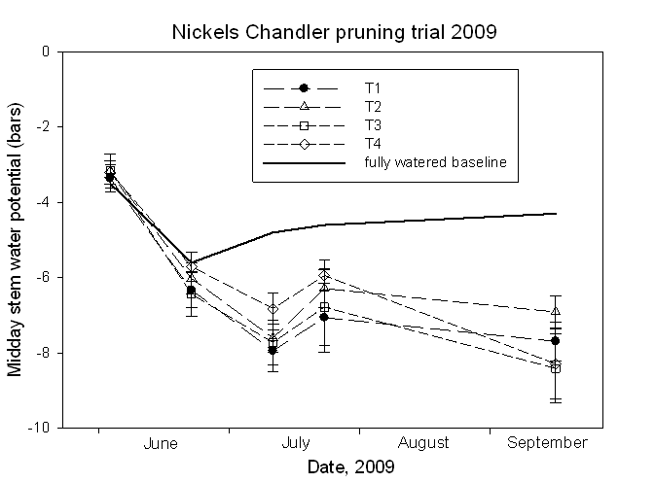

Figure 4. Midday stem water potential (bars) for the four Chandler pruning treatments throughout the 2009 season.



Figure 5. Midday stem water potential (bars) for the different varieties and pruning treatments for the 2010 season.