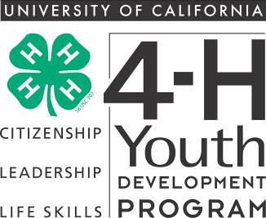


4-H Record Book

Manual

SOLANO COUNTY VERSION

March 9, 2011

Updated March 24, 2011

http://cesolano.ucdavis.edu/4-H_Program/Record_Books

© 2008 The Regents of the University of California

Preface

The State 4-H Incentives and Recognition Advisory Committee has worked for four years updating the 4-H Record Book process. This manual is a summary of that work, as well as a year of testing, review and modification. The guiding principles of the committee throughout this process have been:

- Youth Development: Focusing 4-H Record Books on important skills such as record-keeping, reflection, and self-analysis.

- Consistency: Improving consistency of 4-H record-keeping by standardizing record book formats while still allowing for local flexibility.

- Ease: Updating the 4-H Record Book process to construct an easier procedure and using modern tools such as computers.

- Evaluation: Updating evaluation and recognition systems to current 4-H practices, including the use of criterion judging.

The process and formatting of a 4-H Record Book will depend on an individual 4-H member’s age, experience, and whether the book will be entered into for competition. Many 4-H members will never enter their 4-H Record Book for competition. The valuable life skills, reflection, goal setting, and growth of a 4-H member are the most important aspect of 4-H Record Books.

Steven Worker

State 4-H Program Representative

California 4-H Youth Development Program
University of California
DANR Building, One Shields Avenue
Davis, CA 95616
530-754-8518
http://www.ca4h.org/

With thanks to the 4-H members, volunteers and staff on the 4-H Incentives and Recognition Advisory Committee and the Ventura County 4-H Youth Development Program.

Table of Contents

Preface 2

Purpose of Record Books: Positive Youth Development 4

Process Instructions 8

Formatting Instructions 10

Helpful Hints 11

Organization Overview 13

Section 1: Preliminary Information 14

Title Page Sample 15

Table of Contents Sample 16

Section 2: Personal Development Report Instructions and Sample (page 23) 17

Section 3: My 4-H Story Instructions 33

My 4-H Story Sample 34

Section 4-A: Annual Project Report Instructions 36

Annual 4-H Project Report Sheep Project Sample 37

Annual 4-H Project Report Foods-Nutrition Project Sample with Expression Page 41

Section 4-B: Junior and Teen Leadership Development Report Instructions 46

Junior and Teen Leadership Development Report Sample – Foods-Nutrition 47

Section 5: Collection of 4-H Work Instructions 52

Collection of 4-H Work Samples 53

California 4-H Science, Engineering and Technology (SET) Abilities & Life Skills 56

Suggested Abbreviations 57

Important Things to Remember 58

How to Improve Your Record Book 59

Bringing Service Learning to Every Project 60

Showing Growth and Adding Size to a 4-H Still Life Project 61

Showing Growth and Adding Size and Scope to a 4-H Livestock Project 62

Section 6: Previous Years’ Records 64

Evaluation and Competition 66

Record Book Resources 67

Purpose of Record Books:

Positive Youth Development

History
The California 4-H Youth Development Program has a long history of record-keeping as an activity by 4-H members. In early 4-H history, Record Books focused on project profit and loss and other activities in agricultural and home economics projects. As 4-H moved from a primarily agricultural focus to encompassing suburban and urban clubs, the Record Book process changed. In the 1980’s, the state level Record Book was reformatted to conform to national achievement (which was then eliminated in the early 1990’s) and the core values of the 4-H Youth Development Program. In the 21st century, the 4-H Record Book has undergone another transformation to ensure positive outcomes of youth participating in the 4-H Youth Development Program. Practices have been modified to meet the needs of a changing society. In order for the 4-H Record Book process to pilot youth into prepared and engaged partners within their communities, it has undergone changes to meet the mission of 4-H Youth Development.

The Purpose of Record Books:

4-H Record Books serve a variety of purposes in the California 4-H Youth Development Program. While society has changed, the goals of teaching record-keeping to youth remain the same.

- 4-H Record Books give members an opportunity to reflect on their yearly work. They document their skill development and their learning experiences in a written report. 4-H members measure their achievements and growth in their total years in 4-H.

- 4-H Record Books encourage members to set goals and develop plans to meet those goals. Completion of the Personal Development Report awards 4-H members for participation in 4-H activities, which provides an incentive for participation, learning, and achievement.

- Completing a 4-H Record Book is a process where 4-H members record project and club work. Records management (RM) is an industry-standard practice of identifying, creating, classifying, archiving and preserving records. The 4-H Record Book teaches 4-H members these skills through a standard format.

Youth Development

Youth development is the process through which youth acquire the cognitive, social, and emotional skills and abilities required to navigate life. This development occurs throughout a young person's life, including formal and informal settings such as home, church, school, peer relationships and work experiences. Continued exposure to positive experiences, settings and people, as well as opportunities to gain and refine life skills, supports young people in the acquisition and growth of personal and social assets.

The 4-H Record Book process contributes to positive youth development in several ways:

1) Essential Elements of Youth Development

Research shows that focusing programs on the four essential elements of youth development creates healthy and happy children, who demonstrate a sense of maturity and civic engagement as adults and become stronger individuals, creating stronger families and better communities. These essential elements include belonging (caring relationships), mastery (constructive learning experiences), independence (leadership opportunities), and generosity (service to communities). 4-H Record Books support each of these by:
- Belonging: 4-H members are awarded for their participation in activities, earning symbols of belonging as they continue in 4-H (e.g. stars, achievement pins, etc.).
- Mastery: Through competition, 4-H members receive feedback on their participation and record keeping skills so they can improve and grow.
- Independence: 4-H members are encouraged to participate in leadership development activities (e.g. Junior and Teen Leader, officers, committee chairs, etc.).
- Generosity: 4-H members are provided an incentive to engage in their communities through positive citizenship and community development activities.

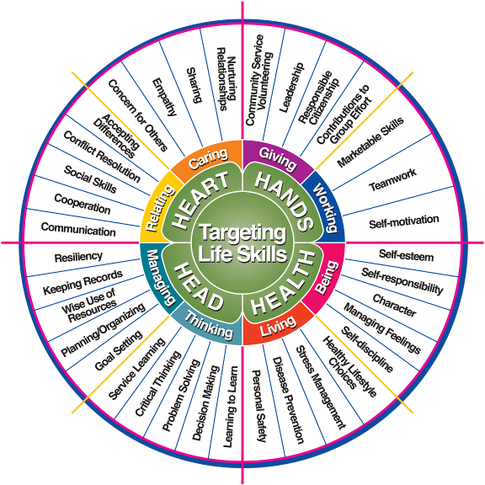
2) Life Skills Focus
Core elements of the 4-H program are Citizenship, Leadership and Life Skills Development. The 4-H Record Book process helps members attain a variety of life skills and focuses on managing, thinking, and relating. 4-H members improve their skills in record keeping, goal setting and communication. Competition serves to critique 4-H members’ feedback on their skill development and provides feedback to improve.

Specifically, in record keeping, 4-H members develop the following life skills:
- Maintaining records of 4-H project and club work, school and community activities.
- Keeping personal and business records.
- Improving communication with other people.
- Learning time management and organizational skills.
- Learning responsibility and developing goal setting skills.

Reference: Iowa State University, “Targeting Life Skills Model.”

Patricia Hendricks, November 1996

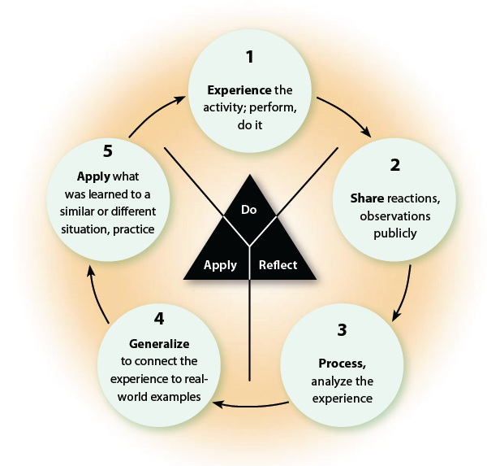3) Experiential Learning Cycle

4-H utilizes a learn-by-doing model called Experiential Learning which engages youth in hands-on activities. 4-H Record Books can play an important role in this process during the reflection stage. 4-H members share and process their experience by recording what they did and learned at each project meeting on the Annual Project Report. This report helps the 4-H member summarize their activities and learning experiences in their projects.

Reference: California 4-H Project Leaders Digest (2007)

4) Learning Strategies
4-H members differ on learning strategies that best shape their ideal learning experience. 4-H volunteer and members must make selections that consider age, developmental stages, and the needs of the group to ensure a positive and enjoyable learning experience.
- Competitive Learning – Competitive learning encourages high levels of individual achievement, but also creates many more losers than winners. This can be harmful to youth. Individualistic Learning – Individualistic learning encourages independence but does not provide participants with any information about their peers. It requires development of standards for youth to work towards. 4-H Record Book competitions may focus on either or both of these types of learning strategies.

- Cooperative Learning – Cooperative learning encourages the development of social interaction skills. Group members learn and experience interacting directly with one another. Every member must be responsible for how he or she does as an individual as well as how the group does. Teaching social skills should be a part of the planned activity because they are necessary for the group to succeed. Completing 4-H Record Book forms can be done in a cooperative learning environment. Combined with the experiential learning cycle, group members can reflect on their project work as a group to gain valuable insight from one another.

Reference: California 4-H Project Leaders Digest (2007)

5) Age-Appropriate Development
The 4-H Youth Development Program is based on the needs and interests of its members. 4-H Record Books must be developmentally appropriate for participants and appropriate for the delivery mode. Expectations of 4-H Record Book completion and standards change as 4-H members become older, more experienced and have gained life skills in 4-H, school and in their community.

- Primary members have a separate format for Record Books that is specifically designed for 5-to-8 year olds. Primary members are not eligible for competition, including 4-H Record Book awards or competition. Primary work is not carried over to the PDR when 4-H'er becomes a regular member.

Ideas for ALL Record Books: Ask 4-H members to write about what they learned and what they did at each project meeting on the Annual Project Report Form.
Junior (9 – 10 years old)
- Participation should be limited to cooperative learning activities with limited competition.
- Junior members should have frequent meetings with work divided into time-limited units. Meetings and group activities are important. Project lessons should be short.
- Junior members should learn about what makes up a community. Learning experiences should involve structured exposure to community work environments.
Ideas for 4-H Record Books:
- Have 4-H members work together on their Annual Project Report, Expression Pages or My 4-H Stories.
- Place a higher emphasis on completing the forms but not on specific formatting guidelines. Do not encourage 4-H Record Book competitions.

- Intermediate (11 – 13 years old)
- Participation should include cooperative learning and individual work with limited competition as an evaluation tool.
- Intermediate members should be encouraged to take an active role in decision-making at the unit level, i.e., committees, officers, and activity planning.
- Intermediate members should be encouraged to assist the younger members. Tasks may be to notify members of meetings, assist the project volunteers with setup or clean up, taking attendance, or demonstrating skills.
- Advanced projects should be offered to those who are interested. Talks, discussions, tours, conferences, and group educational activities are appropriate.
Ideas for 4-H Record Books:
- Have 4-H members show younger members how to complete a 4-H Record Book.
- Allow for creativity on 4-H Record Book forms.
- Encourage 4-H members to focus on providing in-depth information on one or two projects, but perhaps not on all of their projects.

- Senior (14 years old and above)
- Participation should include individual and team work, with limited competition.
- Senior members should be encouraged to take an active role in decision making by providing leadership, such as leading projects and serving as committee chairs or officers. They should participate in implementing and evaluating activities.
- Senior members should be encouraged to identify individual goals, acquire the resources, and do the research to pursue specific interests.
- Senior members should be encouraged to be role models for younger members and provide leadership at the unit, county, and regional levels. Responsibilities may include teaching, program management, event planning, and/or program promotion.
- Senior member involvement should expand beyond the local unit level to county functions, community service, and getting others involved.
Ideas for 4-H Record Books:
- Encourage 4-H members to demonstrate their growth in the 4-H Story, Collection of Work, and Previous Years’ Materials.
- Ask 4-H members to provide detail on what they did and learned on the Annual Project Report Forms.
Reference: California 4-H Policy Manual 403
Process Instructions

4-H Record Books are an educational component of the 4-H Youth Development Program. 4-H Record Books are not required for 4-H membership or for participation in 4-H activities such as club events and activities, or for attending 4-H camps or conferences. 4-H Record Books are not required for receipt of member year pin and stripe. The 4-H Record Book process must be based on educational criteria and approved by county 4-H staff. Notification of 4-H Record Book requirements must be given to the 4-H member at the time of enrollment (ref: 4-H Policy 308.4 I). A 4-H Record Book may be required to receive participation awards (such as star ranking, medals or pins based on Record Book achievements).

Verification of the Completion of 4-H Work

Proper signatures are required to confirm the completion of 4-H work. The 4-H Community Club Leader and Project Leaders approve and verify 4-H work undertaken by the 4-H member. Signatures are required on the following forms:
- The first page/cover of the Personal Development Report: 4-H member, parent or legal guardian, and 4-H Community Club/Unit Leader
- The last page of each Annual Project Report: 4-H member and project leader
- The last page of each Junior and Teen Leadership Development Report: 4-H member and project leader.

Timeline
Counties set their own 4-H Record Book deadline dates. Check with community leaders for the Solano County club and county deadlines. 4-H Record Books are due for State Judging in the Fall. For State Judging: A 4-H Record Book may only contain information and records from the previous 4-H program year (twelve-month period).

Adult Participation
4-H Record Books must be completed by the 4-H member. This includes completing forms, writing the My 4-H Story, and other records. Adults may assist by guiding, explaining, helping to compile information, and proofreading.

4-H Enrollment
Personal Development Report (PDR) member participation and star rankings transfer from one California county to the next. Former participation in other states can be counted in the California 4-H Record Book Personal Development Form with documentation of activities.

Special Accommodations
The core values of the California 4-H Youth Development Program state that we “appreciate, respect and value diversity through a commitment to inclusion of diverse Californians.” Accommodations must be made for 4-H members who cannot complete the 4-H Record Book in the usual format. A note detailing the accommodation must be included with the 4-H Record Book. Examples of accommodations may include:
- Having a 4-H member verbally provide the information while a project leader or parent transcribes.
- Having a project leader or parent assist with assembling materials.
- Other accommodations may be arranged with the advice and approval of the 4-H Community Club/Unit Leader and/or County 4-H Office.

Club & County Interpretation of 4-H Record Book Guidelines
Questions may arise as 4-H members are completing a 4-H Record Book. These questions may regard guidelines for formatting and organization, counting activities on the Personal Development Report, and other related areas of the book. The 4-H Record Book is interpreted in the following manner:
- The 4-H Community Club/Unit Leader (CCL), and his or her designee, provide primary support and interpretation of the 4-H Record Book. The CCL approves and verifies 4-H work undertaken by the 4-H member.
- The County 4-H Incentives and Recognition Committee (name of this committee varies by county) provides training and interpretation support for the county. The Committee is responsible for providing additional instructions and answering questions from 4-H volunteers and members. The Committee plans county Record Book judging including the evaluation and awards process.
- The County 4-H Office oversees all 4-H educational activities, including the 4-H Record Book. The Office is responsible for ensuring that the 4-H Record Book is an educational part of 4-H Youth Development activities.
- State 4-H Office and Statewide 4-H Incentives is responsible for developing the forms and instructions for the 4-H Record Book and instructing county 4-H staff and county I & R committee members on their use. These two entities are responsible for planning the State 4-H Record Book Judging process.

“Children are one third of our population and all of our future.”
~Select Panel for the Promotion of Child Health, 1981
Formatting Instructions

The format of 4-H Record Books will depend on the 4-H member’s age, experiences, and whether he or she is entering the book for competition. While following formatting guidelines is important, the benefits of completing a 4-H Record Book are a positive and important experience.

4-H members completing 4-H Record Books at the project and club level may either handwrite or use a computer to complete each organizational section: Annual Project Reports, Personal Development Report (PDR), My 4-H Story, and Collection of 4-H Work.

Formatting for 4-H Record Book

4-H Record Books must follow these formatting guidelines, unless otherwise stated in the directions specific to that organizational section:

- Must use Solano County record book forms; located at

http://cesolano.ucdavis/4-H_Program/Record_Books/

- Typeface: Books must be handwritten or typed in black ink. Whichever method you choose, it must be the same for the whole record book. If handwritten, text must be written legibly. If typed, font size must be a 12-point in one of the following fonts: Garamond, Arial, Times New Roman, or Helvetica. Font size may differ for headings and emphasis in text.

- Spacing: Text may be single or double spaced (4-H member’s preference).

- Paper: Use 8 ½” x 11” plain white regular paper for all sections. Pages may be double-sided, except for the My 4-H Story which must be single-sided.

- Margins: Use a 1 ½” inside (left) and 1” top, right and bottom margins throughout the book. (if used, page numbers may be outside of these margins)

- Do not exceed page limitations as specified for each section.

- Do not use sheet protectors or laminate any pages, unless enclosing a brochure.

- Folder or Binder: Use an acco type fastener folder or 3-ring binder. The program year, member’s name, county, 4-H club, and address must be included on the cover. (For State 4-H Judging 3-ring binder may not exceed 1 inch.)

- Tabs and Divider Pages: Tabs and divider pages help separate sections and improve overall organization. In Solano County, at the club and county level, divider pages with labeled tabs are used to separate program years. Paper color other than white may be used.

- Graphics: Graphics, pictures, and drawings may be included on the title page, table of contents, expression page(s) and collection of 4-H work. Do not use graphics, pictures or drawings in any other sections or forms.
Helpful Hints

- The Annual Project Report may not exceed 4 pages.
- My 4-H Story may not exceed 6 pages single sided, double or single spaced.
- Start your record book at the beginning of the 4-H year and continue working on it and adding information to it throughout the 4-H year so that there is less work for you to do at the end of the year when your record book is due!
- After each project meeting write a brief statement about what you did and list all you learned during the meeting. In this way, you won’t have to remember so much at the end of the year.
- The project report is a brief summary of what you did in the project; it is kind of like a journal. For each entry you summarize what you did at the project meeting and list the things you learned, in order to show some growth. This is where you add entries about project field trips. List all personal learning experiences in which you participated that are related to the project, like preparing your entries for the fair, reading a book related to the project, etc.
- All information must fit into the space provided in the record book forms. There is one Personal Development Form. There are 3 lengths of Annual Project Report forms: mini, long (experience 2 pages), and long (experience 3 pages). Choose the appropriate length for your record book.
- Photos should show project work, leadership and citizenship activities. Computer generated photos are acceptable. If competing at State level the State requires regular weight paper.
- Photo captions should explain what is taking place in the photo and indicate when and where the photo was taken.
- On the project expression page you do not want to put anything too bulky or fragile in your record book, because it could break or make your record book thick and heavy. Do not let that prevent you from showing your creative side!
- Ask for help from another 4-H member or leader if you are having trouble with your record book.
- Always check your spelling. It is helpful to work on your record book with a dictionary always at hand. Have your record book reviewed for spelling by a 3rd party.
- Do not be afraid of doing a record book; don’t look at it as a huge school project. Look at it as a fun scrapbook or storybook that you will be able to look back on and be proud of later on in life.
- Keep all of your receipts from purchasing supplies for a 4-H project. It will be easier to fill out the expenses section of the Project Report Form.
- Hold onto all of your 4-H correspondence in a 4-H folder or binder so that you can easily find and use it to help you fill out your Personal Development Form at the end of the year. Letters written by or about the 4-H member may be used in the Collection of 4-H Work section.
- Developing goal setting skills is an important part of 4-H. Establish your annual personal development, project, and leadership goals at the beginning of the 4-H year and keep them in a 4-H folder or binder. These are to be summarized in your My 4-H Story.
- Learn from your mistakes.
- 4-H photographs may be used on the Expression page(s) for your Project Report(s) and on up to 5 pages in your Collection of 4-H Work.
- Ask your leaders to sign your record book pages as soon as possible.
- The Program Year is the start of the current 4-H year on July 1st.
- The age you record is your age on December 31 of the current 4-H year.
- Total Years in 4-H include the current 4-H year.
- Use a 1 ½ inch inside (left) margin and 1 inch top, right and bottom margins on all pages throughout your record book. If pages are double-sided use a 1 ½ inch outside (right) margin to prevent things from getting hidden in the binding of your book.
- Never leave any section blank. Either write information in it or if it is not applicable, write “N/A” or “none”. For instance, if you have no expenses in a project, write “No Expenses” in the Expenses and Income/Value section.
- Take a lot of pictures throughout the 4-H year at all your project meetings and events so that you have pictures for your photo pages.
- In any type of Foods - Nutrition Project Report record what you learned about food safety and well-balanced diets and meals.
- Records books may be completed using only ONE of the following methods:
  - Complete all forms and the 4-H Story on the computer
  - Hand write all forms and the 4-H Story
  - Complete all forms on the computer and hand write the 4-H Story
  - Hand write all forms and complete the 4-H Story on the computer

Organization Overview
A 4-H Record Book contains the following items:

Section 1: Preliminary Information
- Title page (optional at club and Solano County level; required for State 4-H Judging)
- Table of Contents (optional at club and Solano County level; required for State 4-H Judging)
- For State Judging:
  - State 4-H Judging Cover Page
  - County Check Sheet

See section 1 instructions for more information, page 14.

Section 2: Personal Development Report (PDR)

4-H members record activities that they have completed during the year. 4-H members may earn stars based on their participation in 4-H over a number of years.

See section 2 instructions for more information, page 17.

Section 3: My 4-H Story

Reflection on 4-H work completed. 4-H members have an opportunity to reflect on their achievements, knowledge gained, learning experiences and project work.

See section 3 instructions for more information page 33.

Section 4: Projects

4-H members document their specific project work including meetings attended, profit/loss in their project, and knowledge and skills gained. Each project should have all materials grouped together.
Example: 1A) Annual Project Report (Sheep) with Expression Page
1B) Junior and Teen Leadership Report (Sheep)
2) Annual Project Report (Energy Management) with Expression Page
3) Annual Project Report (Woodworking) with Expression Page
4) Junior and Teen Leadership Report (Beginning 4-H)
5) Annual Project Report (Leadership Project)
See section 4 instructions for more information, page 36.

Section 5: Collection of 4-H Work

These materials support the previous sections in showing growth and experience in 4-H. They may include the following: newspaper clippings, 4-H flyers or brochures, 4-H letters, 4-H photographs.

See Section 5 instructions for more information, page 52.

Section 6: Previous Years’ Records

4-H members include their previous year’s records at the back of the book. All records are retained (including photographs).

For State Judging Only: Materials from all previous years in 4-H must be removed and replaced with summary pages.

See Section 6 instructions for more information, page 64.

Section 1: Preliminary Information

Title Page (optional at club and Solano County level; required for State 4-H Judging)

A title page introduces the 4-H Record Book at the front of the 4-H Record Book. The page includes the member’s name, 4-H Club, county and the program year. The title page may be a color other than white paper, use graphics, photos and larger text. The title page must not exceed one standard page.

See sample on page 15

Table of Contents (optional at club and Solano County level; required for State 4-H Judging)

A table of contents lists the order of the 4-H Record Book sections. Include the titles of the section headers and page numbers (if used). A 4-H Record Book is organized into the following sections.

See sample on page 16

- Section 2: Personal Development Report
- Section 3: My 4-H Story
- Section 4: Projects. This section includes Annual Project Reports, Expression Pages and Junior and Teen Leadership Development Reports. Each project may have its own subsection or all of the projects may be contained within one section.
- Section 5: Collection of 4-H Work
- Section 6: Previous Year’s Records

For State Judging only:

State 4-H Judging Cover Page

The State 4-H Judging Cover Page must be included with 4-H Record Books entered for State Judging. The Cover Page may not be altered. 4-H Record Books missing the Cover Page will be reason for disqualification.

County Check Sheet

A county check sheet must be included with 4-H Record Books entered for State Judging. A committee, authorized by the County 4-H Office, must complete the checklist and ensure the completeness of the 4-H Record Book. 4-H Record Books missing the Check Sheet will be reason for disqualification.

Both forms are available at http://www.ca4h.org/Resources/Members/RecordBook/RBCompetition

SAMPLE TITLE PAGE

2009 – 2010 Record Book


Suzie Solano





Sunny Skies 4-H Club

Solano County
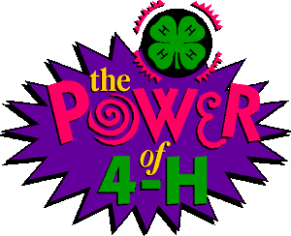
SAMPLE TABLE OF CONTENTS

TABLE OF CONTENTS

2009/2010 Record Book

Section 1: Preliminary Information

Title Page
Table of Contents

Section 2: Personal Development Report

Section 3: My 4-H Story

Section 4: My Projects

1A) Annual Project Report (Sheep) with Expression Page
1B) Junior and Teen Leadership Report (Sheep)
2) Annual Project Report (Foods and Nutrition) with Expression Page
3) Annual Project Report (Woodworking) with Expression Page
4) Junior and Teen Leadership Report (Beginning 4-H)
5) Annual Project Report (Leadership Project)

Section 5: Collection of 4-H Work

Newspaper Articles
Flyers
Brochures
Letters
Photographs

Section 6: Previous Years’ Records (under separate tabs)

Section 2: Personal Development Report Instructions

4-H members record their participation and activities in 4-H and outside of 4-H for the current 4-H program year on the Personal Development Report. Items cannot be counted in multiple categories (known as “double-counting”). However, if a member participates in multiple activities during one event, those separate activities may be counted and attendance at the event may be counted.

See Solano County Personal Development Report (PDR) Support Piece for more information. (Last updated in 7/2009)

http://cesolano.ucdavis.edu/4-H_Program/Record_Books/Solano_County_Personal_Development_Report_Support_Piece/

Additional Space
The Personal Development Report is available in one version: long, at http://cesolano.ucdavis.edu/files/60457.doc or
http://cesolano.ucdavis.edu/4-H_Program/Record_Books.

The 4-H member may add additional pages for each category as needed, but must follow limitations stated below for Outside of 4-H Activities.

Level of Participation
In categories 2 thru 8, the member must identify the level at which the activity took place.

- I = Individual: independent, individual activity, not as part of a group.
- L = Local club, unit, project, club/project committee
- C = County, area/district, multi-club
- M = Multi-county, section, or region
- S = State
- N = National, multi-state
- G = Global, international, crossing U.S. boundaries

Star Achievement Ranks
Star Ranks are designed to encourage members to participate in a wide variety of activities over a number of years. Stars provide 4-H members opportunities to accomplish goals. Each star level takes an average of two years to complete.
(See the second page of the Personal Development Report for more information, sample on page 23.)

Inside versus Outside of 4-H Activities
Up to two significant activities outside of 4-H are allowed in categories 2 and 4 through 7, while other activities outside of 4-H may be counted in category 8. To record activities in categories 2 and 4 through 7, they must meet the instructions and guidelines for the category.

1. 4-H Projects Completed*

* Required for a Star Rank
- Purpose: This category records projects a 4-H member has completed.
- Only 4-H projects with a completed and signed Annual Project Report may be counted. To receive credit, the project report must be included in the 4-H Record Book. Only activities related to the project reports included in the member’s 4-H Record Book may be entered in sections 2 through 7 of the PDR.
- A minimum of FIVE project meetings and TEN hours of project instruction is required to complete a project.
- During the current year, 80% average attendance across all projects is required to receive an achievement rank.

2. 4-H Project Skill Activities
- Purpose: This category records activities where 4-H members either exhibited their 4-H project work or demonstrated their knowledge to an audience and/or judge.
- Exhibits – Report 4-H shows or events and their location where the 4-H member exhibited 4-H work from a 4-H project, committee or club (such as livestock, clothing, food, pictures, artwork, or other project items). 4-H members may receive credit for the same exhibit presented before new audiences at different events.
  - Judged Exhibit – A credit is received for each project exhibited. Multiple entries from one project count as one credit. Projects are defined to be those in which a separate Annual Project Report would be completed. Showmanship is not counted as a separate credit.
    - Example: A 4-H member enters two foods project exhibits at the county fair (a cake and cookies) = 1 credit for foods project.
    - Example: A 4-H member enters a rocket and woodworking exhibit at a 4-H field day = 2 credits. One for rocketry project and one for woodworking project; as long as they are enrolled in each project.
    - Example: A 4-H member enters a lamb at the county fair (in market and showmanship classes) = 1 credit for sheep project.
  - Non-Judged Exhibit – Each show/event counts as one credit (regardless of the number of items/projects exhibited).
Examples of events: Parents’ Night, display at the local library, exhibit for National
4-H Week (not entered in county competition), display at a shopping mall or public building.
- Knowledge Contests – Report participation in any 4-H knowledge bowls, contests or other activities that test a 4-H member’s knowledge.
Examples: Horse bowl, Avian bowl, Horticulture Contest, Champion Challenge.
- Judging Contest - Report participation in any 4-H judging contest where the 4-H member judged with other 4-H members by a set of standards.
Examples: Judging Day, Livestock Judging Day, Club Judging Contests, Judging Contest.
- Note: Youth may not participate as 4-H members nor will their participation be recognized as a 4-H experience in jackpot or prospector shows (4-H Policy 410.2).
- Project Skill Activities Outside of 4-H – must pertain to activities conducted within a project for which an annual report has been completed.

3. 4-H Events Attended
- Purpose: This category records 4-H events, other than 4-H Club and project meetings, that the 4-H member attended during the year.
- 4-H events are authorized and publicized functions other than regular club or project meetings. Record events not reported elsewhere. Optional or voluntary 4-H events outside the normal club and/or project expectations may be counted here. Multiple day events count as one credit (e.g. county fair, conferences, etc.).
Examples: Club Holiday Dinner (not at a regular club meeting), Club Invitational, District, County, Sectional, and State Field Days, Achievement Night, California or Washington Focus, State 4-H Leadership Conference, Teen Leader Conference, County Fair Awards Ceremony, Fashion Revue, Horse Bowl, Equine Play Days and Livestock Clinics, Leadership Training Workshops, Project Training Workshops, and National 4-H Conference.
- Note: 4-H members may receive credit for actively participating at an activity during the

event and attending the event.

Example: Giving a presentation at County 4-H Presentation Day (PDR #6 Communication Skill) and attending the County 4-H Presentation Day (PDR #3 Event Attended).

See Solano County Personal Development Report (PDR) Support Piece for more information.

4. Leadership Development*

* Required for a Gold or Platinum Star Rank
- Purpose: This category records leadership activities undertaken by the 4-H member.
- Officer - This includes 4-H offices held at the project, club, county, sectional, or state level.
- Committee Chairperson - Report the committee at the club, county, sectional, or state level where the 4-H member served as a Chairperson or Co-Chair. Include 4-H camp counselors or director’s positions, Chairperson or Co-Chair positions.
- Committee Member - Report the number of committees at the club, county, sectional, state, and national levels where the 4-H member actively participated as a committee member.
Examples: Club Phone Tree, Fundraising Committee, Club party committee, Clean up committee, Decorations committee, and County event committee.
- Note: 4-H members cannot receive credit for both chairperson and committee member for the same committee.
- Junior and Teen Leader* - This refers to the completion of one year as a Junior and Teen Leader. A credit is given for each project the 4-H member led and completed a Junior or Teen Leadership Development report form. Solano County requires Junior and Teen Leaders to participate in a Leadership Project and to complete both the Annual Project Report form for Leadership and Junior and Teen Leadership Development Report(s).
* Required for a Gold or Platinum Star Rank
- Note: The duties 4-H members perform as an officer, committee chair or member or a junior and teen leader are considered part of a position and cannot be counted as separate items for any category on the PDR. Examples: giving officer’s report, chair or junior/teen leader reports or talks at 4-H project or club meetings, attending separate officers’ meetings.
- Planned a 4-H Group Activity - An activity is a planned piece of work actively designed, coordinated, or organized by 4-H members, usually on a one-time basis, which benefits other members, volunteers or community members.
- Leadership Development Project – Count participation here as well as additionally counting this as a separate project and filling out an Annual Project Report form.
- Served as a Judge – Where the 4-H member served as a judge for a 4-H activity or contest.

5. Citizenship & Community Service*
* Required for a Star Rank
- Purpose: This category records citizenship and community service activities undertaken by the 4-H member.
- Report participation where the 4-H member takes an active part in a planned, publicized, and approved citizenship, service-learning or community service activity. Count credits by activity or event. Optional: The member may include the number of hours participated for informational purposes.
- Count a re-occurring activity or event each time the activity occurs (e.g. monthly visit to a convalescent home may count each visit, monthly recycling program, monthly canned food donation).
- Members conducting fundraising activities for personal benefit cannot count the activity under Citizenship/Community Service.
- Community Service Project - encompasses any humane act serving the common good; in the interest of the community.
Examples: Canned food drive, visit to convalescent home, beach clean-up, warm coat drives, toy drives, volunteering at a homeless shelter, project linus, giving blood.
- Service Learning Project – an authentic activity that combines service and learning to address a real community need; allows one to apply learning to a community problem in collaboration with others. It includes structured time for reflection on the service experience. Examples: storm drain painting where students learn about water issues, a disability awareness program where students raise money for March of Dimes, an environmental field studies program that involves working to protect wetlands.

Citizenship Activities may include the following, provided they are planned, publicized, and approved.
- Personal Development and Self-Esteem – Acquire life skills to become an active responsible member of one’s family, community, state, and nation. Examples: conduct a community safety program, participate in a youth group exchange, help to establish year-long goals for a citizenship project.
- History and Cultural Heritage – Develop awareness and understanding of cultures and heritage of one’s family and others. Examples: prepare an exhibit on local history/artifacts, organize an international heritage or foods festival, participate in historic event, tour historic sites, and participate in an international exchange.
- Government Studies – Develop knowledge of the principles, processes and structures of government. Examples: attend a Citizenship Focus conference, write a letter to a Congressperson about
4-H, attend City Council or Board of Supervisors meetings to talk about 4-H, assist with voter registration drives, assist with elections, participate in a mock trial, lead a flag salute at a 4-H event.
- Environmental Issues – Develop awareness and understanding of environmental issues and the human impact.
Examples: work on a community or beach clean-up, develop an exhibit on conservation, build wildlife habitats, and participate in environmental public hearings.
- Societal Concerns and the Citizen’s Role – Develop awareness of societal issues and respond to the needs and rights of others through responsible social action. Examples: study local issues and share ideas about solutions, hold a community forum, work with food share programs, visiting convalescent homes and hospitals, identify hunger, land use, pollution or energy issues, help disseminate information and help develop solutions.

6. Communication Skills*
* Required for a Star Rank
- Purpose: This category records communication activities undertaken by the 4-H member.
- 4-H Presentations* - To receive credit each 4-H presentation must be presented before a new audience at a new event. Repeating the 4-H presentation at the same event does not count as two credits. All 4-H presentation types outlined in the State 4-H Presentation Manual are accepted. You may not use a graded school project presentation as a 4-H presentation. Giving a practice 4-H presentation does not count as a credit (e.g. practicing for family).
* Required for a Star Rank
- Prepared Talks relating to 4-H where the 4-H member reports informational or educational material before a project group, 4-H Club, County 4-H Council, school or other community groups. This does not include officer’s reports or committee reports. Talks must be prepared in advance of the meeting or activity and be approved by the Community 4-H Club Leader.
- Radio and Television Appearances - Report appearances as a participant before a radio or TV audience in connection with 4-H. Members must be actively involved for credit.
Examples: Guest speaker on radio, and telethons.
- Newspaper Articles - Report the number of times the 4-H member wrote and submitted an article connected with 4-H for publication. If article was not published, submit a copy to the 4-H Community Club/Unit Leader (CCL) and retain the original for your records to receive credit. Do not include articles written about the 4-H member.
Examples: Articles relating to 4-H that 4-H member wrote and submitted to local papers, school papers, Club Newsletter, and the County web site.
Note: Officers whose job includes writing and submitting articles may not receive credit. Examples. Club Reporter articles submitted to local newspaper, Newsletter Editor articles submitted to club newsletter.
- Representing 4-H – Record activities where the member represented 4-H by communicating with 4-H, school, or community audiences. The member must be clearly identified as a 4-H member.
Note: Members may obtain a credit for appearing in 4-H identification in public only during National 4-H Week.
Examples: Leading the 4-H Pledge, represent 4-H as a room host or hostess, commentator, master/mistress of ceremonies, work at a 4-H information booth, etc.
- On-Line Communication – Record activities where the member created or supported a
4-H website or moderated a 4-H email list for a 4-H group or activity.

7. Honors and Recognition
- Purpose: This category records the significant honors and recognition earned by the 4-H member.
- Record significant and notable honors, awards and recognition received in the 4-H YD Program. Do not include ribbons (unless it is the highest award given), seals, or certificates on the Personal Development Report (PDR). Include these on the Annual Project Report Form in the (List honors or awards earned) box. The intent of this category is to award significant honors, not necessarily only the single highest honor.

Note: The names and titles of many recognitions vary within the state. Please use the examples provided here only as a guideline.

The County 4-H Incentive & Recognition Committee may create additional guidelines specific to their county.

Examples: Star ranks, County Winner, 100% Club Attendance, Emerald Star, County, Sectional and State Presentation Day Gold Award, County and State 4-H Record Book Winner, 1st Place Fair Feature Booth, Project Skills Day Showmanship Award, Fashion Revue Winner, Project Proficiency attainment, County All Star Ambassador or State Ambassador, Golden Clover Award, Best of Show, Best of Division. NOT Counted: 1st place ribbons & awards, Presentation Day red or blue awards, Participation awards, Special awards.
- In criterion-based (Danish) 4-H competition, the top placement may be counted. For example: a Best of Show Award, Best of Division, Outstanding 4-H Exhibitor may be counted if it is the highest placement in a judging.
- In peer-to-peer (American) 4-H competition, the 1st place of a division and 1st place overall may both be counted. For example, a 4-H member may count 1st place senior showmanship and 1st place Round Robin. Examples: Grand Champion, Reserve Grand Champion, Best of Class, Best of Breed, Best of Division, Best of Show, Director’s Award, 1st place Showmanship (in each division: novice, junior, intermediate, senior), 1st place Herdsmanship Award, 1st place Round Robin, 1st place Supreme Showmanship, 1st place Carcass. NOT Counted: 1st place market class, 2nd place Showmanship.
- Outside of 4-H Honors and Recognition examples: Boy or Girl of the Quarter/Year at school, Eagle Scout, Honor Roll, champion sports team, music awards.

8. Lifestyle Activities (4-H and Outside of 4-H)
- Purpose: This category records lifestyle activities both in and outside of 4-H that the member participated in.
- Report participation in larger organized groups or activities such as camps, community or school sports, music, theater and the arts, employment, church, or organizations.
Examples: music or dance lessons, school or science outdoor camp, horseback riding lessons, church choir, organizational memberships.
- Each organization, group, activity, or sport counts as one credit per 4-H year.
- 4-H lifestyle activities may count in this category.
Examples: 4-H Camp, 4-H skits or song leading, 4-H drama or sport group.
Examples that do NOT count: Individual activities such as family outings, vacations, taking care of pets, homework, normal school work, and hobbies (e.g. listening to music, skateboarding, etc.).

“Children are our most valuable natural resource.” ~ Herbert Hoover

California 4-H Youth Development Program

Personal Development Report

Your picture
(optional)

County: __Solano_______________________________

Name of 4-H Club/Unit: __Sunny Skies 4-H________________

Program Year: _2009-10____ Total Years in 4-H: __8_______

(Include years as a primary member)

Name: __Suzie Solano____________________

Birth Date: ___02/18/1994____ Gender:  Male  Female

Age on December 31: __16______ Grade in School:___10th
(of the program year listed above)

Address: ___123 Clover Lane_____________________________

City: __Fairfield______________________ State: __CA__ Zip: __94533_____

Email: ___Ilove4H@4Hrocks.net________ Phone: (_707_)_123-4567__________

A minimum completed club 4-H Record Book consists of the following items.
- Section 2: Personal Development Report (PDR)
- Section 3: My 4-H Story
- Section 4: Projects - One project report form for every project completed
- Download forms at http://cesolano.ucdavis/4-H_Program/Record_Books/

Club Meetings Attended This Year  During the current year, 80% attendance is  required for any achievement rank  Do not include project meetings. | Meetings Held | Meetings Attended | Percent Attended
 | 9 | 9 | 100%

I have personally prepared this report and believe it to be correct.
Member’s Signature: Suzie Solano | Date: 8/1/10
I have personally reviewed this report and believe it to be correct.
Parent/Guardian Signature: Mrs. Solano. | Date 8/1/10
4-H Community Club/Unit Leader’s Signature: Mrs. Leader | Date: 8/1/10
4-H Star Ranking

Record what you accomplished during the year. To qualify for any of the achievement rank awards, you must attend 80 percent of both the local club and the project meetings held during the year. To obtain any of the ranks, you must complete the asterisked (*) categories as a part of your total effort.
Bronze Star: Complete at least 5 of the 8 categories listed.
Silver Star: Complete at least 6 of the 8 categories listed.
Gold Star: Complete at least 7 of the 8 categories listed.
Platinum Star: Complete at least 7 of the 8 categories listed.
Star Ranks are designed to encourage members to participate in a wide variety of activities over a number of years. The bronze, silver, gold, and platinum stars build on past achievements.

Categories of Participation  Transfer credits from previous years to the column headed “Total From Past Years.” | Total Past Years | Total This  Year | Total All Years | Number of Different Categories Required
 |  |  |  | Bronze  5 Required | Silver  6 Required | Gold  7 Required | Platinum  7 Required
- 4-H Projects Completed | 18 | 8 | 26 | 2* | 4* | 8* | 12*
- 4-H Project Skill Activities | 25 | 18 | 43 | 4 | 8 | 15 | 20
- 4-H Events Attended | 49 | 29 | 78 | 12 | 25 | 40 | 60
- Leadership Development | 28 | 21 | 49 | 10 | 20 | 30* | 40*
Junior or Teen Leader | 3 | 1 | 4 | (0) | (0) | (2*) | (4*)
- Citizenship &  Community Service | 16 | 18 | 34 | 10 | 20* | 30* | 40*
- Communication Skills | 52 | 23 | 75 | 12* | 24* | 36* | 48*
4-H Presentations | 11 | 4 | 15 | (4*) | (7*) | (10*) | (15*)
- Honors and Recognition | 42 | 25 | 67 | 5 | 10 | 15 | 20
- Lifestyle Activities  (4-H and Outside of 4-H) | 30 | 11 | 41 | 10 | 20 | 30 | 40
* Required for Star Rank
Numbers contained within parenthesis are included in the total category number (not an extra requirement).

Star Rank
4-H Member must be currently enrolled in the 4-H Youth Development Program.

Present Rank: [] None [] Bronze [] Silver Gold [] Platinum

Rank Applying for: [] None [] Bronze [] Silver [] Gold Platinum

[] Approved  Not Approved ____ Mrs. Leader _________________8/3/10
4-H Club/Unit Leader's Signature Date
Personal Development Report: Participation – Page 3/10

1. 4-H Projects Completed This Year
Star Requirements: Bronze 2, Silver 4, Gold 8, Platinum 12
Total Past Years:___18____ Total This Year: __8______ Total All Years:__26___
During the current year, 80% average attendance across all projects is  required for any achievement rank. | Meetings  Held | Meetings Attended | Percent Attended
- Arts & Crafts | 7 | 7 | 100%
- Cattle-Beef | 12 | 12 | 100%
- Clothing & Textiles | 12 | 12 | 100%
- Foods - Nutrition | 7 | 7 | 100%
- Leadership Development | 11 | 11 | 100%
- Ornamental Horticulture | 10 | 9 | 90%
- Rabbit | 10 | 9 | 90%
- Sheep | 8 | 7 | 88%
TOTALS | 77 | 74
AVERAGE |  |  | 96%

Personal Development Report: Participation – Page 4/10
Include your specific involvement (attended, competed, presented, etc.) and the level of participation:
I = Individual, L = Local Club/Unit/Project, C = County/Area/District,
M = Multi-county/Section, S = State, N = National/Multi-State, G = Global
You may add a page for each category, if needed.

2. 4-H Project Skill Activities
Star Requirements: Bronze 4, Silver 8, Gold 15, Platinum 20
Total Past Years:___25____ Total This Year: __18_____ Total All Years:__43____
Date | Level | List type of activity |  | Location
07/23/09 | C | Judged Exhibit: Clothing Project |  | Solano Co. Fair
07/24/09 | C | Judged Exhibit: Foods Project |  | Solano Co. Fair
07/25/09 | C | Judged Exhibit: Sheep Project (market, |  | Solano Co. Fair
 |  | showmanship)
07/26/09 | C | Judged Exhibit: Rabbit Project (rabbit, |  | Solano Co. Fair
 |  | showmanship, educational display)
07/31/09 | L | Non-Judged Exhibit: Rabbit, Sheep, Arts & |  | Vacaville Library
 |  | Crafts Projects
08/26/09 | S | Judged Exhibit: Foods Project |  | CA State Fair
09/04/09 | S | Knowledge Contest: Avian Bowl |  | CA State Fair
10/04/09 | C | Non-Judged Exhibit: National 4-H Week Display |  | Fairfield, CA
01/09/10 | C | Judged Exhibit: Project Skills Day |  | Vallejo, CA
01/11/10 | L | Judging Contest: Sunny Skies 4-H Club |  | Club Meeting
02/20/10 | C | Judging Contest: Presentation Day |  | Vacaville, CA
03/29/10 | M | Knowledge Contest: Horticulture Contest |  | UC Davis
05/07/10 | C | Judged Exhibit: Clothing Project |  | Dixon May Fair
05/08/10 | C | Judged Exhibit: Foods Project |  | Dixon May Fair
05/13/10 | M | Judged Exhibit: Cluster Fashion Review |  | UC Davis
05/29/10 | S | Judged Exhibit: State 4-H Fashion Revue |  | UC Davis
Project Skill Activities Outside of 4-H (List up to two significant project skill activities, related to projects with a completed Annual Project Report)
01/26/10 | L | Judged Exhibit: Green Valley Art and Craft Contest | Fairfield, CA
03/08/10 | S | Judging Contest: Gold Country Sheep Producers Educational Field Day | Roseville, CA
 |  | Total Number: |  | 18
Personal Development Report: Participation – Page 5/10
Include your specific involvement (attended, competed, presented) and the level of participation:
I = Individual, L = Local Club/Unit/Project, C = County/Area/District,
M = Multi-county/Section, S = State, N = National/Multi-State, G = Global
You may add a page for each category, if needed.

3. 4-H Events Attended
Star Requirements: Bronze 12, Silver 25, Gold 40, Platinum 60
Total Past Years:___49____ Total This Year: __29_____ Total All Years:__78____
Date | Level | List type of activity | Location
08/06/09 | S | State Leadership Conference | UC Davis, CA
08/17/09 | L | Sunny Skies Enrollment Night | Sunny Skies Mtg.
08/19/09 | L | Sunny Skies New Family Orientation | Fairfield, CA
09/01/09 | S | California State Fair Rabbit Bowl | Sacramento, CA
09/05/09 | S | California State Fair | Sacramento, CA
09/19/09 | M | Sectional Leaders Council Meeting | Sonoma County
10/06/09 | C | Solano County Achievement Night | Vallejo, CA
10/24/09 | S | Horse Day Symposium | U C Davis, CA
10/23/09 | C | Solano County Harvest Fair | Dixon, CA
11/05/09 | C | 4-H Club Invitational Ice Cream Social | Sunny Skies Mtg.
01/09/10 | C | Solano County Project Skills Day | Rio Vista, CA
01/13/10 | S | State 4-H Rabbit Field Day | Rohnert Park, CA
01/22/10 | M | C.A.L. Conference | Walker Ranch, CA
02/13/10 | L | Sunny Skies 4-H Club Career Night | Sunny Skies Mtg.
02/27/10 | M | North Central Sectional Council Meeting | Santa Clara Co.,Ca
02/20/10 | C | Solano County Presentation Day | Fairfield, CA
03/10/10 | C | Solano County Record Book Workshop | Fairfield, CA
04/09/10 | M | Sectional Presentation Day | UC Davis, CA
04/14/10 | L | 4-H Club Event Night: Dogs 4 Diabetics Speaker | Sunny Skies Mtg.
04/26/10 | C | Dixon May Fair Horse Show | Dixon, CA
05/06/10 | C | Dixon May Fair 4-H Dog Show | Dixon, CA
05/09/10 | C | *Dixon May Fair | Dixon, CA
05/13/10 | M | Fashion Revue | San Joaquin Co.
05/27/10 | C | Solano County 4-H Sr. Recognition Reception | Fairfield, CA
05/29/10 | S | State 4-H Field Day | UC Davis, CA
06/23/10 | C | Solano County Fair Still Life Awards Ceremony | Vallejo, CA
06/24/10 | C | Solano County Fair Auction | Vallejo, CA
06/27/10 | C | *Solano County Fair | Vallejo, CA
07/03/10 | M | San Joaquin County 4-H Camp | Silver Lake, CA
 |  | Total Number: | 29

* Inclusive of all other shows and events attended during attendance at fair.
Personal Development Report: Participation – Page 6/10
Include your specific involvement (attended, competed, presented, etc.) and the level of participation:
I = Individual, L = Local Club/Unit/Project, C = County/Area/District,
M = Multi-county/Section, S = State, N = National/Multi-State, G = Global
You may add a page for each category, if needed.

4. 4-H Leadership Development
Star Requirements: Bronze 10, Silver 20, Gold 30, Platinum 40
Total Past Years:___28____ Total This Year: __21_____ Total All Years:__49____
Required: Junior/Teen Leader Development Report
Total Past Years: __3__ Total This Year: __1__ Total All Years:_4___
Gold = 2 Platinum = 4 Met Requirement _X__YES ___NO
Date | Level | Type of leadership activity | Location
07/22/09 | C | Solano County Fair: Barn Clean Up | Vallejo, CA
08/01/09 | L | 2009-10 Sunny Skies 4-H Club Treasurer | Fairfield, Ca
08/01/09 | C | 2009-10 Solano County Youth Area Rep. | Fairfield, Ca
08/01/09 | C | 2009-10 I & R Committee Member | Fairfield, Ca
08/10/09 | S | State Leadership Conference-Youth Floor Coord. | UC San Diego, CA
09/01/09 | L | 2009-10 Junior Leader Foods & Nutrition Project | Sunny Skies Mtg.
09/01/09 | L | 2009-10 Leadership Development Project Mbr. | Sunny Skies Mtg.
10/01/09 | L | Cans & Plastic Bottles Recycling Program Chair | Sunny Skies Mtg.
10/04/09 | C | Co. Achievement Night Clean-Up Com. Mbr. | Fairfield, CA
11/01/09 | C | Co. Leadership Retreat-Icebreaker Com. Co-Chair | Fairfield, CA
12/15/09 | L | Holiday Party Committee Chairperson | Sunny Skies Mtg.
12/15/09 | L | Solano Co. Leadership Retreat Com. Member | Sunny Skies Mtg.
01/09/10 | C | Project Skills Day – Judge | Rio Vista, Ca
01/22/10 | M | CAL Conference - Cabin Leader | Walker Ranch, CA
02/20/10 | C | Presentation Day – Room Host | Vacaville, CA
04/10/10 | M | Sectional Presentation Day - Judge | UC Davis, CA
05/13/10 | M | Fashion Revue-Refreshment Comm. Chair | San Joaquin Co.
06/12/10 | L | Planned 4-H Group Activity - Baking Wksh K-3 | Foods K-3 Mtg.
07/01/10 | M | San Joaquin County 4-H Camp - Junior Counselor | Silver Lake, CA
Leadership Development Outside of 4-H (List up to two significant leadership activities)
08/26/09 | I | 2009/10 Link Crew Leader | Green Valley High
08/20/09 | L | PAL Competitive Soccer Team – Captain | Fairfield, CA
 |  | Total Number: | 21

Personal Development Report: Participation – Page 7/10
Include your specific involvement (attended, competed, presented, etc.) and the level of participation:
I = Individual, L = Local Club/Unit/Project, C = County/Area/District,
M = Multi-county/Section, S = State, N = National/Multi-State, G = Global
You may add a page for each category, if needed.

5. 4-H Citizenship & Community Service
Star Requirements: Bronze 10, Silver 20, Gold 30, Platinum 40
Total Past Years:__16_____ Total This Year: __18_____ Total All Years:___34___
Date | Level | Type of citizenship activity | Hours  (optional) | Location
08/15/09 | L | Developed 2009/10 Club Program | 3.75 | Sunny Skies 4-H Club
 |  | Planning Guide
09/01/09 | N | Cartridges For Kids Recycling | 0.25 | Sunny Skies 4-H Club
10/03/09 | C | All-Star Presentation to Solano Co. | 3.50 | Fairfield, CA
 |  | Board of Supervisors
10/20/09 | C | Harvest Fair Peanut Butter Drive | 0.50 | Dixon, CA
10/21/09 | C | Park Clean-Up - Solano Co. | 4.00 | Vacaville, CA
 |  | Tobacco Free Parks Comm.
11/14/09 | L | Food Drive – County Food Bank | 0.25 | Sunny Skies 4-H Club
12/18/09 | I | Learned about needs of battered | 4.25 | Heather House,
 |  | families/ planned holiday activity |  | Fairfield, CA
12/23/09 | L | Distributed Christmas Cards & | 1.50 | Loyalton of Rancho
 |  | visited elderly |  | Solano, Fairfield, CA
01/26/10 | M | Flag bearer - opening ceremonies | 0.25 | CAL Conference
02/12/10 | L | Cans & Plastic Bottle Recycling | 0.30 | Sunny Skies 4-H Club
03/15/10 | L | Cans & Plastic Bottle Recycling | 0.25 | Sunny Skies 4-H Club
04/21/10 | M | Sectional Citizenship Conference | 12.00 | Stockton, CA
05/12/10 | S | Toured California State Capitol | 1.25 | Leadership Proj. Mtg.
05/12/10 | S | Toured CA Museum for History, | 2.00 | Leadership Proj. Mtg.
 |  | Women & the Arts
05/22/10 | C | Undercover tobacco "buys" with | 4.50 | Suisun & Dixon, CA
 |  | the Solano Co. TPEP
6/25-29/10 | S | Attended California Focus | 60.00 | Sacramento, CA
Citizenship/Community Service Outside of 4-H (List up to two significant citizenship activities)
06/20/09 | N | Walked in Relay for Life with volleyball team | 5.00 | Green Valley High School
07/14/09 | G | Hosted PAL-HFC United Soccer Player | 720.00 | Fairfield, CA
 |  | Total Number:  (Total numbers of activities are counted for the Star Rank.) |  |  | 18

Personal Development Report: Participation – Page 8/10
Include your specific involvement (attended, competed, presented, etc.) and the level of participation:
I = Individual, L = Local Club/Unit/Project, C = County/Area/District,
M = Multi-county/Section, S = State, N = National/Multi-State, G = Global
You may add a page for each category, if needed.

6. 4-H Communication Skills
Star Requirements: Bronze 12, Silver 24, Gold 36, Platinum 48
Total Past Years:___52____ Total This Year: __23_____ Total All Years:__75____
Required: 4-H Presentations Total Past Years: _11_ Total This Year: _4_ Total All Years:_15___
Bronze = 4 Silver = 7 Gold = 10 Platinum = 15 Met Requirement _X__YES ___NO
Date | Level | Type of communication activity | Location
07/01/09 | L | Farmers Market Petting Zoo-talked with public | Vacaville, CA
07/25/09 | L | 2009-10 Updated Sunny Skies Club Website | Fairfield, CA
07/26/09 | C | Solano County Fair: Barn Activities | Vallejo, CA
09/01/09 | S | CA State Fair 4-H Booth | Sacramento, CA
09/11/09 | L | Prepared Talk: State Leadership Conf. Report | Club Meeting
10/03/09 | L | 4-H Week: wore uniform/gave 4-H bookmarks | Green Valley High
11/01/09 | C | County Leadership Retreat - Session Presenter | Fairfield, CA
11/12/09 | L | Prepared Talk: Harvest Fair Report | Club Meeting
01/12/10 | L | Article: Clothing Project | Sunny Skies Times
01/26/10 | M | CAL Conference Session Presenter | Walker Ranch, CA
02/24/10 | C | Presentation: Smoke Today...Die Tomorrow | Pres. Day
03/24/10 | M | Presentation: Smoke Today...Die Tomorrow | Sect. Pres. Day
04/10/10 | L | Presentation: Smoke Today...Die Tomorrow | Club Meeting
04/10/10 | L | Prepared Talk: Leadership Project Report | Club Meeting
05/12/10 | C | Dixon May Fair Auction Runner | DMF, Dixon, CA
05/12/10 | C | KCRA-Interview about 4-H participation | DMF, Dixon, CA
05/20/10 | C | Article: Clothing Project | Solano Notes
05/26/10 | S | State Presentation Day: Room Host | UC Davis, CA
05/30/10 | L | Presentation: Smoke Today...Die Tomorrow | Leadership Project
06/04/10 | C | Article: Sunny Skies 4-H Club Helps Out | Daily Republic
06/13/10 | C | Led 4-H Pledge-County 4-H Council Meeting | Fairfield, CA
Communication Development Outside of 4-H (List up to two significant communication activities)
09/06/09 | L | Article: Healthier Vending Food Choices | Green Valley High School Paper
05/01/10 | L | Interviewed for news article Marine Biology Club | Green Valley High School Paper
 |  | Total Number: | 23
Personal Development Report: Participation – Page 9/10
Include your specific involvement (attended, competed, presented, etc.) and the level of participation:
I = Individual, L = Local Club/Unit/Project, C = County/Area/District,
M = Multi-county/Section, S = State, N = National/Multi-State, G = Global
You may add a page for each category, if needed.

7. 4-H Honors/Recognition
Star Requirements: Bronze 5, Silver 10, Gold 15, Platinum 20
Total Past Years:____42___ Total This Year: ___25____ Total All Years:__67____
Date | Level | Honor or Recognition | Location
07/22/09 | C | Solano County Fair Best of Show – Clothing | Vallejo, CA
07/23/09 | C | SCF-Small Animal Supreme Showmanship-1st | Vallejo, CA
07/24/09 | C | SCF-Market Cattle-Beef Grand Champion | Vallejo, CA
07/25/09 | C | Solano County Fair-1st Place Clean Pen Award | Vallejo, CA
08/10/09 | S | Golden Clover Award | UC San Diego, CA
09/01/09 | S | CA State Fair Best of Class - Pound Cake | Sacramento, CA
09/11/09 | L | 100% Attendance | Sunny Skies 4-H Club
10/01/09 | C | Gold Star Rank | Fairfield, CA
10/01/09 | C | Foods & Nutrition Record Book-Co. Winner | Fairfield, CA
10/01/09 | C | County Treasurer Record Book – Co. Winner | Fairfield, CA
10/01/09 | C | Presentation Proficiency | Fairfield, CA
10/01/09 | C | Gold Club Charter Seal | Fairfield, CA
10/01/09 | C | Emerald Star | Fairfield, CA
10/05/09 | C | National 4-H Week Window Display-1st Place | Fairfield, CA
01/10/10 | C | Project Skills Day - Showmanship Award | Vallejo, CA
02/21/10 | C | Presentation Day - Gold | Vacaville, CA
04/10/10 | M | Sectional Presentation Day - Gold | U C Davis, CA
04/10/10 | M | Sectional Presentation Day, Cultural Arts-Gold | U C Davis, CA
05/08/10 | C | Dixon May Fair Parade Float - 1st Place | Dixon, CA
05/29/10 | M | Fashion Revue Senior Winner | U C Davis, CA
05/29/10 | M | State Field Day – Gold Presentation | U C Davis, CA
05/29/10 | M | State Field Day Cultural Arts - Gold | U C Davis, CA
06/08/10 | C | Lynne Burns Memorial 4-H Scholarship | Fairfield, CA
Honors and Recognition Outside of 4-H (List up to two significant honors)
11/06/09 | M | 1st Team MEL Volleyball | Fairfield, CA
06/04/10 | L | 4-H Valley High School Principal's Honor Roll | Fairfield, CA
 |  | Total Number: | 25

Personal Development Report: Participation – Page 10/10
Include your specific involvement (attended, competed, presented, etc.) and the level of participation:
I = Individual, L = Local Club/Unit/Project, C = County/Area/District,
M = Multi-county/Section, S = State, N = National/Multi-State, G = Global
You may add a page for each category, if needed.

  - 8. Lifestyle Activities (4-H and Outside of 4-H)
Star Requirements: Bronze 10, Silver 20, Gold 30, Platinum 40
Total Past Years:___30____ Total This Year: __11______ Total All Years:___41___
Date | Level | Activity or Organization | Type of Participation
09/01/09 | N | 2009/10 National Honors Society | Member
09/01/09 | L | 2009/10 Church Youth Group | Member
09/01/09 | N | 2009/10 A.R.B.A. | Member
09/01/09 | L | 2009/10 Marine Biology Club | Member
09/01/09 | M | 2009/10 Volleyball - High School Team | Player
09/01/09 | M | 2009/10 Volleyball - Club Team | Player
09/01/09 | M | 2009/10 H. S. Marching Band – Flute | Performer
09/01/09 | M | 2009/10 H. S. Orchestra – Flute | Performer
09/01/09 | M | 2009/10 H. S. Drum Line – Xylophone | Performer
02/24/10 | M | Sectional Presentation Day - Cultural Arts | Performer
04/10/10 | S | State Presentation Day - Cultural Arts | Performer
 |  | Total Number: | 11

Section 3: My 4-H Story Instructions

On separate sheets of paper, write OR type your 4-H story. The 4-H story is an opportunity for you to share your experiences in the 4-H program. Your story should be a record of all years in 4-H and emphasize your current year in 4-H. Use the page length recommendations outlined below. (Not to be considered limitations.) DO NOT EXCEED 6 PAGES.

- Junior (or first year member): 1 – 2 pages
- Intermediate: 2 – 4 pages
- Senior: 3 – 6 pages

Examples are available and you may upload your 4-H Story on the State 4-H Website to share with others. More information is available at http://www.ca4h.org/Resources/Members/RecordBook/4-HStories

The following outline may help you in developing your story.

Part 1 - About You.
- How old are you and when did you join 4-H?
- Why did you join 4-H?
- What are your interests and hobbies?
- What are your future and career plans?

Part 2 – 4-H Projects and Activities.
- What projects have you taken? How successful were they?
- What goals did you set and which ones did you reach?
- What would you do differently if you were to try it again?
- What skills have you learned in the program?
- Have your projects grown in size and scope?
- How have you arranged for financing, if needed?
- Were any adults or other 4-H members especially helpful to you? How?

Part 3 – Leadership and Citizenship.
- What do leadership and citizenship mean to you?
- Has 4-H helped you become a better leader and citizen? How? What types of citizenship or leadership projects have you been involved in?
- How have you contributed to 4-H, your community, and your school?
- Describe the most important offices you have held and the committee assignments you have accepted.
- What have you learned from working with other 4-H'ers as a junior or teen leader?

Part 4 – 4-H’s Impact on You.
- What kinds of relationships have you had with your 4-H leaders?
- How has your 4-H participation changed how you feel about yourself?
- How has your participation influenced your school and career goals?
- What has being a 4-H member meant to you?
My 4-H Story
My name is Suzie Solano. I am 16 years old and have been a member of 4-H for the past 8 years. I joined the Sunny Skies 4-H Club as a primary member in 1st grade, because I was going to all the meetings anyway with my older brother and it looked like fun. I live in Green Valley, California with my parents, 2 older brothers and 1 younger sister. It was tough for me to really focus on 4-H this year, because I had so much going on outside of it. I became more actively involved in soccer, which took up a lot of time. I tried out for and made my high school's freshmen volleyball team. This was my first year in high school and the homework and whole high school thing was a little overwhelming at first. I am also active in my church youth group. I enjoy reading, watching television and baking in my “spare” time. Baking helps to relax me when I become stressed out.
This year I decided I needed to cut back a bit on the number of 4-H projects I was going to do, because I was aware of all the things I was going to be involved with at my new high school. I was hoping to decrease the amount of stress I’d be under this year by doing this. But, even with the cut back on projects, it was still tough for me to fit everything in. My responsibilities as a teen leader and club treasurer took up a lot of time. I must admit that I feel I should have done a better job in these leadership roles this year. I plan on being more organized next year and try to plan farther ahead so I won’t be doing everything at the last minute. By the end of the year, however, everything ended up working out fine and I still managed to enjoy and learn a lot in all the projects I took and all the leadership roles I took on.
In the Foods and Nutrition Project this year I ended up taking on a lot of new responsibilities as the teen leader for the project. At the project meetings, I spent more time working as the leader, than participating in the actual cooking and baking activities. It was cool being able to share what I know about cooking and baking with other members. It was a little disappointing that I wasn't able to learn that much from the other members though, because none of them have been involved with foods and nutrition for that long. I was able to learn little tricks from the leader though, which I will start using when I prepare meals and bake at home. I think that I was defiantly able to reach the goals that I set for myself at the beginning of the year, of becoming more organized, improving my time management skills and becoming more comfortable speaking in front of audiences. By making things like Ginger Pumpkin Cheesecake, Lemon-Peppered Chicken Sauté, Pork Buns, bagels, and various pastries, I was able to really challenge myself. By teaching others what I know about baking, cooking and food safety, I was able to improve my own skills and techniques, because you always get better at things when you teach them to other people.
I probably learned the most this year in the Computer Project. I think my biggest accomplishment this year in this project was just being able to keep up with the rest of the project members. When I joined the project, I knew basically nothing about computers. My goal was to learn the basics about using a computer and all the different programs. All the other members were really into computers, so they already knew a lot about them. At first, it was a huge struggle for me to remember all the different terms and stuff that is commonly used while working with computers. It was almost like listening to the rest of the members talk in a different language at the beginning of the project. But, I slowly caught onto to what they were talking about and what all the terms mean. By the end of the year I was able to at least understand what they were talking about, although I don't think I am yet ready to join in on their conversations and sound intelligent. Even though I only learned the basics, it was still a lot for me and I was able to meet my goals for the year. I have started start using what I've learned on my computer at home and have even made a power point presentation for school. Learning how to put together a web page, though, will take a while longer.
I learned a lot about myself in the Leadership Project this year. I discovered my style of being a leader and will be able to use what I've learned to help make myself a better leader. At the beginning of the year, we took a personality test that helped us discover what type of leader and person we are. I learned that I am mostly a peacemaker, but I am also a little bit of an activator/organizer. I also learned that I am an introvert. I tend to not want to be in the spot light. Instead, I support other people and only become the vocal leader when it is needed. At the beginning of the year, I thought that leaders were only the people that are always voicing their opinion and leading a bunch of people all by themselves. But, by the end of the project, I discovered that shy people, like me, are also leaders, in their own way, even though we prefer to work in groups of people instead of by ourselves. Without introverted people, everyone would be extroverted and no one would listen to each other. Group projects would probably not work out very well. I learned that by having all different types of leaders, things turn out well and everything ends up running smoothly. Through the Money Talks program, I learned a lot about how to use my money wisely, budget, and that saving really pays off in the long run. Overall, I think I will be able to everything I learned in this project in all parts of my life.
In the many years that I have been involved in 4-H, I have learned a lot about becoming a better leader and citizen. I have been able to develop my own personal leading style, which emphasizes my individual strengths. I have taken on more difficult leadership positions every year, increasing my leadership responsibilities. As a club Treasurer for the past 3 years, I have learned how critical it is to keep thorough and accurate records. By being an officer for 5 years, I have been able to make a difference within my 4-H club. I have also begun to work on county committees, which allows me to expand my influence even more and let my ideas and opinions be heard. In 4-H, I have learned the importance of serving your community. My community supports me and it is important to give something back. By serving as a 4-H officer, teen leader, and committee chair and member, I am able to give and share some of my time and talents with other youth in my 4-H community. At every opportunity I try to help make 4-H the best possible program it could be.
4-H is a great program which has helped me grow and learn a tremendous amount over the past 8 years. It has helped prepare me for school tasks by teaching me organization and better public speaking and presenting skills. I have more confidence when presenting at school or any where else, because of all the speaking opportunities I have had in 4-H. It has presented me with a comfortable learning environment in which I feel open to taking risks and growing as a leader and citizen. I know that all the skills I have learned so far in 4-H, and the ones I will learn as my involvement continues, will help advance me toward college and what ever career I choose to pursue. 4-H has given me many of the tools I need to succeed in life, and I am applying them to my life all of the time. During my next 4-H year, I want to really challenge myself when it comes to baking. I also want to go to at least one conference next year, be a teen leader, and try to become a better overall leader. I have already been elected my club’s Vice President for next year and I hope that I will do a good job. I had a very good year during 4-H and I hope that next year will be just as good.

Section 4-A: Annual Project Report Instructions

Projects provide the basic framework for 4-H teaching and learning experiences. Projects provide cooperative learning opportunities, a well-documented context for effective learning. Each year 4-H members will participate in at least one project. A project is:
- Planned work in an area that is of interest to the 4-H member.
- Aimed at planned objectives that the 4-H member can attain and measure.
- Guided by a 4-H adult volunteer.
- Summarized by some form of record keeping.

A minimum of FIVE project meetings and TEN hours of project instruction is required to complete a project. The county 4-H YDP staff must approve all county or unit requirements for project completion.

Completing this Section

This section is used by the 4-H member to document their specific project work. Place items in the following order for each separate project:
- An Annual Project Report form for every project the member has completed.
- Expression page (optional)
- Junior/Teen Leadership Development Report, specific to that project.
Download forms at http://cesolano.ucdavis.edu/4-H_Program/Record_Books

Section 4-A: Annual Project Report Form
There are 3 lengths of Annual Project Report forms: mini, long (experience 2 pages), and long (experience 3 pages). Choose the appropriate length for your record book. In the Learning Experiences box, explain what the 4-H member did, learned, and life skills gained in the project during the year. This includes activities that took place during project meetings, shows, and events. The life skills wheel may be helpful in identifying the life skills gained in the project. The 4-H member may record items raised, grown or improved, honors and awards, citizenship and leadership activities, and profit/loss in the boxes provided. Entries in the two boxes (List citizenship activities and List leadership activities) must pertain to activities conducted within the project being reported. In addition to top awards, ribbons and awards other than top awards may be recorded in the box (List honors or awards earned). The 4-H member may decide to document simulated "money" from the project in the profit/loss box if it is relevant to the project.

Each Annual Project Report form completed and signed by the Project Leader counts as a separate project on the PDR (under #1 Projects Completed). OPTIONAL: County All Stars, 4-H State Ambassadors, members involved in a domestic or international exchange or Emerald Star project may record their participation as a project and fill out an Annual Project Report and a Junior and Teen Leadership Development Report signed by the team advisor.

The Annual Project Report may not exceed four pages.

Expression Page (Optional)

4-H members may include one Expression page, for each Annual Project Report, on which the 4-H member has an opportunity to creatively show something they learned in the project. If completed, page must be one side of an 8 ½” x 11” piece of paper and adhere to formatting instructions. See page 10. The 4-H member may draw, write, and use his/her imagination! Although it is optional, it is highly recommended.

California 4-H Youth Development Program

Annual Project Report
Submit one form per project.
Name | Suzie Solano | Program Year |  | 2009/2010
Project | Sheep Project | Years in Project |  | 2
10 | Number of project meetings held |  | 100 | % Attended
10 | Number of project meetings attended |  | 100 | % Attended

LEARNING EXPERIENCES
Date | Explain what you did, what you learned, and what life skills you gained in the project during the year.  Include the level of participation:  I = Individual, L = Local Club/Unit/Project, C = County/Area/District,  M = Multi-county/Section, S = State, N = National/Multi-State, G = Global | Level
07/24/2009 | Solano County Fair - exhibited one market lamb. | C
08/25/2009 | Attended the California State Fair. Watched the Junior Sheep Show, showmanship and market. | S
09/29/2009 | Project Meeting 1: We talked about our goals for this year. My goal is to improve in showmanship. We talked about | L
 | topics we will cover this year. We looked at the equipment we will need and learned we need to wear leather boots for safety.
10/21/2009 | Project Mtg. 2: Learned about sheep diseases and those that sheep can pass on to humans. Learned how to recognize a | L
 | sick sheep. I prepared a handout about biosecurity and we discussed how to practice biosecurity at home and at the fair.
11/18/2009 | Project Meeting. 3: Learned about sheep behavior and safe sheep handling. Took a quiz about safe sheep handling. I | L
 | learned that sheep should be handled with patience and in a calm, quiet manner.
01/15/2010 | Project Meeting 4: A feed company representative talked to our project. We learned about the ingredients in lamb feed. | L
 | I also learned that sheep need hay because they are ruminants and hay is good for their rumen.
01/29/2010 | Went to a lamb sale in Dixon. I bought a lamb. I named him Petey. He weighed 82 lbs. | I
02/10/2010 | Project Meeting 5: We went to a sheep auction. Our leader taught us how to choose a good market lamb. We focused on | M
 | what qualities are desirable in a good market lamb and the importance of buying a lamb of the right weight for your fair.
02/15/2010 | Gave a prepared talk at Sunny Skies 4-H Club meeting about my sheep project meeting. | L
02/20/2010 | Presentation Day: Educational Display about different sheep breeds and their wool. | C
03/08/2010 | Ear tagging for Dixon May Fair. Petey weighed 105 lbs. | C
03/09/2010 | Project Meeting 6: I missed this meeting. | L
04/03/2010 | I gave a prepared talk to a Beginning 4-H project: Basic information about sheep. | L
04/17/2010 | Project Meeting 7: We practiced showmanship and talked about our responsibilities at the fair. I learned that what will | L
 | help me improve in showmanship is practice. We learned about bracing our lambs and I am working on it at home.
04/20/2010 | I got a lamb for Solano Fair. We went to Red Bluff to buy him. His name is Ranger. | I
05/08/2010 | Dixon May Fair. I got fifth in junior showmanship, 3rd in market class. | C
05/09/2010 | Project Meeting 8: We met at Dixon May Fair to talk about the fair and how our project members’ lambs were doing. | L
05/17/2010 | Solano Fair ear tagging. Ranger weighed 112 lbs. | C
06/05/2010 | Three weeks before the Solano County Fair I continued to practice showmanship every day after dinner. I learned some | I
 | tips about shearing my lamb from an older project member.
06/08/2010 | Project Meeting 9: We watched a movie about ethics. I learned about the proper places to give shots, when to give shots, | L
 | and what shots could be given before the fair. All of this information was given about the market animal which will be
 | sold at auction. It should not be infected or in poor condition. I will use this information when raising my lambs for the fair.
06/10/2010 | Make-up Meeting: Had a showmanship clinic at another leader’s ranch. Everyone from all the clubs and FFA were | L
 | invited to bring their lambs. I learned from watching the other showmen. A local ag teacher was the judge and explained what
 | judges want to see. We received a booklet about the different cuts of lamb.
06/30/2010 | Project Meeting 10: I talked about my educational display about wool sheep and the different types of wool they produce. | L
 | Everyone really liked my display! We watched a showmanship video. Our leader helped us with record books.

Project Report Form (Continued)

Number Made | List things made, raised, grown,  or improved. |  | List honors or awards earned *1
2 | Crossbred Market Lambs |  | DMF Showmanship 5th place
 |  |  | DMF Market Ready Lamb
 |  |  | SCF Showmanship: 4th place
 |  |  | Solano Fair Market Ready Lamb
 |  |  | Solano Fair: Clean Pen - 1st Place
*1 Cumulative awards/ribbons
List citizenship activities *2 | List leadership development activities *2
Learned about the winter needs of Solano | 2009-2010 Jr. Leader, Sheep Project
County homeless; collected wool blend | Helped plan Countywide Sheep
socks for distribution by Mission Solano. | Showmanship Clinic
 | Hosted Sheep booth at Solano County
 | Fair Ag Day, 1300, 3rd grade students
 | participated.
*2 Must be related to the project.
Expenses and Income/Value
Summarize, totaling all expenses such as: ingredients, feed, vet supplies/visits, materials, exhibitor's fees, and all income such as: value of finished products, animals sold, exhibit premiums, etc.
Item | Number | Expense | Income  or Value
Crossbred Market Lamb | 2 | $ 500.00 | $1,356.00
Feed: #16 bags lamb feed & #4 bales alfalfa | 20 | $ 280.00 | $ 0.00
Equipment: cart, feeder, padlock w/key, halter | 4 | $ 100.00 | $ 75.00
Shavings - bales | 8 | $ 50.00 | $ 0.00
Vet Supplies: Wormer, antiseptic, shots | 3 | $ 50.00 | $ 7.00
Dixon May Fair Entry Fees/Premiums | 1 | $ 13.00 | $ 0.00
Solano County Fair Entry Fees/Premiums | 1 | $ 13.00 | $ 8.00
 |  | $ | $
 |  | $ | $
 |  | $ | $
 |  | $ | $
 |  | $ | $
 |  | $ | $
 |  | $ | $
 |  | $ | $
 |  | $ | $
 |  | $ | $
 |  | $ | $
 | Totals | $1,006.00 | $ 1,446.00
Total Profit or Loss |  | $ 440.00

If you plan to take this project next year, what would you like to learn?
I would like to broaden my knowledge about sheep. I would like to participate in a
wool animal project, so I might do a breeding project. I enjoy showing sheep.

I have personally prepared this report and believe it to be correct.
4-H Member’s Signature: Suzie Solano | Date: 7/25/09
I have personally reviewed this report and believe it to be correct.
4-H Project Leader’s Signature: Mrs. Leader | Date: 7/26/09

California 4-H Youth Development Program

Annual Project Report
Submit one form per project.

Name | Suzie Solano | Program Year |  | 2009/2010
Project | Foods - Nutrition | Years in Project |  | 4
6 | Number of project meetings held |  | 100 | % Attended
6 | Number of project meetings attended |  | 100 | % Attended

LEARNING EXPERIENCES
Date | Explain what you did, what you learned, and what life skills you gained in the project during the year.  Include the level of participation:  I = Individual, L = Local Club/Unit/Project, C = County/Area/District,  M = Multi-county/Section, S = State, N = National/Multi-State, G = Global | Level
7/22/09 | Baked for Solano County Fair. | I
8/26/09 | Baked for California State Fair. | I
9/6/09 | Project Mtg 1: We went to a Taste of Home Cooking Show. This was a first for me and it turned out to be a fun and | L
 | educational experience. The chef used a lot of cool supplies and equipment that I had never heard about before. I also
 | learned a lot of different shortcuts to use while cooking, that will make my cooking easier in the future.
10/27/09 | Project Mtg 2: Today we made Ginger Pumpkin Cheesecake. The hardest part for me was shaping the crust made out of | L
 | crushed ginger snaps and butter. It kept falling down off the sides of my spring form pan. While the cheesecakes were
 | baking, we calculated the recipe's cost and discussed our future plans for this year's project. Our theme will be dishes
 | from around the world, focusing on a different country for each project meeting.
11/23/09 | Helped church youth group prepare meals for local homeless shelter for Thanksgiving. | L
12/2/09 | Project Mtg 3: We made Russian Tea Cakes, also called Mexican Wedding Cookies. I learned how to finely chop nuts, | L
 | without turning them into powder, and how to properly hold my fingers while chopping. I had a hard time shaping the
 | cookies into small enough balls, considered acceptable for this type of cookie.
1/26/10 | Project Mtg 4: We attended the Solano Co. Food Safety Training Workshop. I reviewed and refreshed what I learned | L
 | last year about how to keep food safe, precautions needed when storing food, and safe hand washing techniques. I will
 | teach all this food safety information to the K-3rd Foods & Nutrition Project for which I am a Junior Leader.
2/20/10 | Pres. Day: Illustrated Talk "How to Make Yeast Bread". | C
3/30/10 | Project Mtg 5: We were given a food budget of $50 to shop at Raley’s for a party of ten people. I learned how hard it | L
 | is to stay within a budget, shop for good deals, and to throw a reasonably priced party.
4/5/10 | Gave a prepared talk about this project to the Sunny Skies 4-H Club. | L
4/10/10 | Sect. Pres. Day: Illustrated Talk "How to Make Yeast Bread". | M
4/12/10 | Project Mtg 6: We went to a mini cooking show at Bel Air Market in Folsom. I learned more cooking shortcuts and tips. | L
 | We noticed the chef wasn't using good food safety skills. He didn't always wash hands between handling raw meat and
 | vegetables and didn't cook his meat to a temperature that was safe.
4/16/10 | My dad took me to meet with a client about their kitchen renovation. I learned what people consider when laying out | I
 | their kitchen, whether they cook a lot or just occasionally & the triangle you should make between refrigerator, stove & sink.
5/5/10 | Baked for Dixon May Fair. | I

Project Report Form (Continued)

Number Made | List things made, raised,  grown, or improved. |  | List honors or awards earned *1
1 | Pumpkin Cheesecake |  | Solano Co. Fair: 15 - 1st Place
72 | Russian Tea Cakes, (6 dozen) |  | Ribbons, 2 - 2nd Place Ribbons
1 | Patio Potato Salad |  | Solano Co. Fair: 4 – 3rd Place
2 | Lemon-Peppered Chicken Sauté |  | Ribbons
4 | Herbed New Potatoes |  | Solano Co. Fair: 1st Place
3 | Lemon Yogurt Loaf |  | Sweepstakes Trophy
360 | Christmas Cookies, (30 dozen) |  | Solano Co. Fair: 4-H Best of Show
12 | Family dinners |  | CA State Fair: Best of Class
 |  |  | Dixon May Fair: 11 - 1st Place
 |  |  | Ribbons, 2-2nd Place Ribbons
 |  |  | Dixon May Fair: Overall Best of
 |  |  | Show Award
 |  |  | Dixon May Fair: 2 - 4-H Special
 |  |  | Award Ribbons

*1 Cumulative awards/ribbons
List citizenship activities *2 | List leadership development activities*2
Learned about the needs of battered | 2009-10 Jr. Leader Foods-Nutrition Proj.
families/planned holiday activity making | Planned 4-H Group Activity-Baking
Gingerbread houses at Heather House. | Workshop K-3 Members
 | Fashion Revue-Refreshment Committee
 | Chair

*2 Must be related to the project

Expenses and Income/Value
Summarize, totaling all expenses such as: ingredients, feed, vet supplies/visits, materials, exhibitor's fees, and all income such as: value of finished products, animals sold, exhibit premiums, etc.
Item | Number | Expense | Income  or Value
Cooking Show Tickets | 2 | $30.00 | $ 0.00
Quick Cooking Magazine | 12 | $17.98 | $17.00
Illustrated Talk Presentation Supplies | 1 | $9.86 | $ 0.00
Equipment: thermometer & cooling racks | 3 | $31.59 | $31.59
Canning Session | 1 | $ 0.00 | $ 0.00
Food Supplies: project and fairs | 0 | $211.34 | $368.50
Dixon May Fair Entry Fees/Premiums | 1 | $15.00 | $70.00
Solano County Fair Entry Fees/Premiums | 1 | $16.00 | $73.00
California State Fair Entry Fees/Premiums | 1 | $10.00 | $25.00
 |  | $ | $
 |  | $ | $
 |  | $ | $
 |  | $ | $
 |  | $ | $
 |  | $ | $
 |  | $ | $
 |  | $ | $
 |  | $ | $
 | Totals | $361.77 | $585.09
Total Profit or Loss |  | $223.32

If you plan to take this project next year, what would you like to learn?
I would like to learn how to make more difficult pastries, breads and cakes; better
manage my time when making a meal and baking; and use different types of
cooking equipment such as a wok, microwave oven, baking stone, and barbeque.

I have personally prepared this report and believe it to be correct.
4-H Member’s Signature: Suzie Solano | Date: 7/25/10
I have personally reviewed this report and believe it to be correct.
4-H Project Leader’s Signature: Mrs. Leader | Date: : 7/25/10

EXPRESSION PAGE SAMPLE

WHAT COLORED PRODUCE CAN DO FOR

YOU




RED: healthy heart, good memory and urinary tract health, and lowers risk of some cancers. Examples are cherries, cranberries, raspberries, strawberries, red apples, red grapes, red and pink grapefruit, red peppers, tomatoes, and watermelon.
WHITE: rich in phytochemicals. Examples are bananas, cauliflower, garlic, mushrooms, white-flesh peaches/nectarines, white onions, and white potatoes.



















BLUE or PURPLE:
lowers risk of some cancers, urinary tract health, good memory and healthy aging. Examples are blueberries, blackberries, prunes, raisins, eggplant, plums, and purple grapes.
GREEN: strong bones and teeth, rich in phytochemicals. Examples are artichokes, asparagus, avocados, broccoli, cabbage, cucumbers, green apples, green beans, green peppers, green grapes, green pears, honeydew, kiwi fruit, lettuce, spinach, and peas.
YELLOW or ORANGE:
lowers risk of some cancers, healthy heart, good vision and healthy immune system. Many yellow and orange colors of produce are rich in beta-carotene, vitamin C, carotenoids and bio-flavonoids. Examples are cantaloupe, carrots, nectarines, peaches, apricots, oranges, papayas, mangoes, pineapple, corn, and sweet and yellow potatoes.
Section 4-B: Junior and Teen Leadership Development Report Instructions

The 4-H Junior and Teen Leadership experience is designed to provide members with the opportunity to learn about the qualities and competencies needed to be a leader. Leadership is not doing things for the group, it is helping the group decide what needs to be done and how. Junior Leaders provide assistance while Teen Leaders assume more challenging leadership roles. Junior and Teen Leaders may assist with specific projects or with other 4-H activities or events. A 4-H member may be a Junior or Teen Leader for one or more projects during the year. The major duties of a Junior or Teen Leader are (varies by age, experience, and other factors):
- Work collaboratively with the adult leader to set goals, develop lesson plans, teach skills, and evaluate the activity.
- Coordinate logistical details such as meeting times, locations, materials and supplies, and expenses with the adult leader.
- Communicate with the adult leader and members about group expectations, responsibilities and expected outcomes.

At the beginning of the year, the 4-H member and the adult leader should meet to discuss the project and define each of their roles. The 4-H member should complete pages 1 & 2 of the form. At the end of the year, the 4-H member must complete pages 3 & 4 of the form and include the entire form in his/her Record Book to receive credit.

Junior Leaders (Intermediate Members): To become a junior leader, youth must be in grades 6-8, or if home-schooled, must be at least 11 and no more than 13 years old as of December 31 of the program year.

Teen Leaders (Senior Members): To become a teen leader, youth must be in the ninth grade or above, or if home-schooled, must be at least 14 years old as of December 31 of the program year.

Completing the Junior and Teen Leadership Development Report
Each Junior or Teen Leadership Development Report form completed and signed by the Project Leader (or team advisor) counts as a separate credit on the PDR (under #4 Leadership Development). This form may be completed for any 4-H leadership development activity, including County All Star, 4-H State Ambassador, those involved in a domestic or international exchange, or Emerald Star project. The 4-H member must fill out an Annual Project Report and a Junior or Teen Leadership Development Report signed by the team advisor. Solano County requires Junior and Teen Leaders to participate in a Leadership Project and to complete both the Annual Leadership Project Report and Junior and Teen Leadership Development Report(s).

The 4-H member may add one page for a total maximum of six pages to answer the questions on the Junior and Teen Leadership Development Report.

Note: There may be cases where the 4-H member is a Junior or Teen Leader for a project but does not actively participate in the project. In this case, the 4-H member will fill out the Junior and Teen Leadership Development Report and not the Annual Project Report for any K-3 project they are leading. A credit is given in the PDR for a Junior and Teen Leader and not for a project completed.

Example. K-3 Beginning 4-H Project.

California 4-H Youth Development Program

Junior and Teen Leadership Development Report
Submit one form per project for which you were a Junior or Teen Leader.
May submit one form per Leadership Development Activity, e.g. Emerald Star.
Add no more than 1 additional page, if needed, to answer all of the questions.

Name |  | Suzie Solano |  |  |  | Program Year |  | 2009/2010
Project |  | Foods - Nutrition |  |  |  | Years in Project |  | 4
Club |  | Sunny Skies 4-H |  |  |  | Number of Members |  | 8
Project Leader’s Name |  |  | Mrs. Leader
[] | Leadership Development Project |  |  | [] | Junior Leader |  | [X] |  | Teen Leader

Complete questions 1 – 3 before the project or activity begins:

1. Briefly describe the overall project or activity. What is the project or activity and why is it important?

The Foods & Nutrition Project will focus on meal preparation this year. It is

important for the members to learn about the food pyramid, healthy food

choices, and eating well balanced meals. It is also important for members to

learn the basic techniques needed to prepare meals, including slicing, chopping,

mixing ingredients adequately, and using equipment such as the stove top,

oven and electric mixer. In order to remain safe in preparing meals, members

need to learn all safety rules related to the equipment and foods they will be

handling. The theme for the Foods & Nutrition Project this year will be meals

throughout the day: breakfast, lunch, dinner, and snacks. This is important

because members need to learn how to balance food choices throughout the

whole day and week. Members will be given the opportunity to help choose the

foods prepared in each meal, so that their favorite foods and dislikes can be

taken into consideration. I am looking forward to having a lot of fun with the

Members in this project this year!

Junior and Teen Leadership Development Report (Continued)

2. Goals
- Record the goals you have for this project or activity. What do you hope this project or activity accomplishes?
- Record your personal goals for your own leadership development. At the end of the project or activity, what do you hope to have learned?

In the Foods & Nutrition Project this year all members will learn about kitchen

and food safety; appropriate food preparation techniques; planning meals that

are healthy and well balanced; shopping for the ingredients needed to prepare a

meal; and basic terminology used in cooking. I also want members to have

fun and to treat other members with respect and kindness. Each member

should learn something new at every project meeting, appropriate to their level

of learning and age. I will work on my ability to teach other members new

techniques without doing the task for them; to patiently support and work with

people less experienced than myself so they can learn and grow at their own

pace; to plan ahead; and to listen to the project leader so that both of us are

happy and can work in harmony together.

3. Project Plans: Explain your project plans and the actions you will take to complete this project or activity.

The Foods & Nutrition Project will meet monthly, beginning in October and

ending in May. After talking with the project members I will choose appropriate

recipes, gather supplies needed, make a list of ingredients that need to be

purchased and give it to the leader, and figure out the best way to complete meal

preparation within an hour and a half. At the end of each meeting members will

share the meal they have prepared, family style. October ~ lunch; November ~

breakfast; December ~ holiday treats; January ~ shopping field trip; February ~

dinner; March ~ dinner; April ~ help members make choices of foods to enter in

the Dixon May Fair & snacks; May ~ members choose the meal we will prepare;

June ~ possible meeting to talk about Solano County Fair and record books.

Approval of Plans
I have personally prepared this report and believe it to be correct.
4-H Member’s Signature: Suzie Solano | Date: 9/24/09
I have personally reviewed this report and believe it to be correct.
4-H Project Leader’s Signature: Mrs. Leader | Date: 9/25/09

Junior and Teen Leadership Development Report (Continued)

Complete questions 4 – 7 after the project or activity concludes:

4. What were your roles and responsibilities in this project or activity? What was your purpose, what did you do and learn?

In preparation for the Foods & Nutrition Project this year, I was responsible for

developing goals and an overall theme for the project. I decided it was important

for members to learn meal planning strategies for every meal throughout the day

rather than focusing solely on dinners. Throughout the year I was responsible for

working with the project members planning their next project meeting; working

with my project leader to figure the best way to accomplish all the work needed

to complete the project meal within the two hour meeting time; finding

appropriate recipes for the desired dishes; developing a list of ingredients and

equipment needed; gathering all supplies and ingredients needed for the meal;

and notifying my leader within a reasonable time about food items that needed

to be purchased. At the start of each meeting I taught and reviewed with the

members food and equipment safety issues directly related to that meal's

preparation. During the meetings I was responsible for overseeing and working

with the smaller groups that the members were divided into. Toward the end of

the year, I became responsible for running the meetings entirely on my own,

with little assistance from the project leader. I passed on the knowledge I have

gained about foods and nutrition to the project members, along with my

enthusiasm and love for cooking. I think each member learned about safety,

nutrition, meal planning and a variety of food preparation techniques. More

importantly, the members seemed to enjoy the project a lot. Most project

members started preparing meals at home for their families and we were able to

make our own cookbooks, as a final activity for the project! I learned a lot about

working with younger members. I had to carefully evaluate the difficulty of the

recipes I used, making sure my project members could both understand them

and perform the individual tasks required. I would match the members varied

abilities and attention spans with the things that needed to be accomplished

to complete the project meal. I also learned how to creatively encourage

members when they became discouraged and when they did not want to try a

new food.

Junior and Teen Leadership Development Report (Continued)

5. What specific leadership skills did you develop?

I have learned a variety of teaching and management skills. I have learned that

you have to keep the meeting moving along, otherwise members become bored.

It is hard to get them re-focused and interested again, and your meal doesn't get

completed in the time available. I also learned that you have to be patient when

teaching someone a new skill, because they may not always get it the first time

they try it. Sometimes you have to teach things in a different way, depending on

the individual member's learning style. I learned that sometimes it may be best

to step back and not help when it looks like one of the members is having

trouble with something. It may be easier for that member to work through their

frustration and find a way that works for them individually, rather than trying to

get them to use what works best for me. I became a better speaker in front of

groups, because I led the project group at each meeting. I also became more

organized, developed an ability to designate job tasks that need to be completed,

and improved my time management skills by helping to lead this project. I also

learned the importance of planning ahead and keeping good records.

6. How will you use the skills you learned in future 4-H and other activities?

I will apply the teaching, speaking, organizational, time management,

planning and record keeping skills that I have learned as a Teen Leader for the

Foods & Nutrition Project this year to projects that I choose to help lead in the

future. I will also use them in the other 4-H leadership roles in which I serve, for

instance as an officer, session presenter, committee chairperson, and event

planner. It will be easier to work with my club members and other 4-H

members, because of the teaching skills I have learned this year. I will also be

able to use all of these skills in my life at school and as a member of my

volleyball teams. I plan to help tutor younger students at my school next year

and continue on as a Link Crew member. All that I have learned teaching

project members this year will help in those activities a lot.

Junior and Teen Leadership Development Report (Continued)

7. For the Project Leader: Please provide feedback and comments on the 4-H member’s leadership role.

Suzie did a great job this year! She planned and taught almost every meeting for the

project this year. She worked extremely well with the project members and was able to

help advance their skills in cooking, baking, and meal planning. She was able to

basically run the Foods and Nutrition Project this year, with a little supervision at

the project meetings.

Approval of Report
I have personally prepared this report and believe it to be correct.
Member’s Signature: Suzie Solano | Date: 7/25/10
I have personally reviewed this report and believe it to be correct.
4-H Project Leader’s Signature: Mrs. Leader | Date: 7/26/10

Section 5: Collection of 4-H Work

The Collection of 4-H Work is a section at the end of the Record Book that acts as a portfolio to support the other sections of the 4-H Record Book. A Collection of 4-H Work allows the 4-H member to demonstrate some of their activities during the current 4-H program year. The Collection of 4-H Work is limited to 11 pages and follows the standard formatting and paper guidelines except as noted below.

The following items may be included. Items may be compiled in any order.

Newspaper or Newsletter Articles 2 pages maximum

Limited to two pages, single-sided.

Newspaper or newsletter articles must be written by the 4-H member or about the 4-H member. Articles may not be shingled. They must be firmly attached to the page. Digital copies or printouts from on-line sources are acceptable.

Flyers or Brochures 2 pages maximum
Limited to two full pages, single or double sided. Double-sided entries are considered one page.
Flyers or brochures must feature the member or must have been created by the member. Brochure may be attached to a standard sheet of paper or included in a sheet protector.

Letters 2 pages maximum
Limited to two pages, single-sided.
Letters may either be written by the 4-H member or about the 4-H member. A two page letter is considered two pages and meets the maximum page limitations.

Photographs 5 pages maximum
Limited to five pages, single-sided.
Photographs should show project work, leadership and citizenship activities. Captions for each photo should explain what is taking place in the photograph and indicating when and where the photograph was taken. Space used for captions counts as part of the five pages. Pictures may not be shingled. They must be firmly attached to the page (no “flip-ups”). Digital or computerized photos are acceptable. Please use a normal weight paper if submitting to State competition.

Total: 11 pages maximum

Note: In order to save space and offer multiple examples, the Solano County sample Collection of 4-H Work is NOT formatted to the above guidelines. All members must follow the above guidelines when completing their record books.

"Creativity takes courage." - Henri Matisse
SAMPLE Collection of 4-H Work
VACA VALLEY 4-H STARS
AT THE LIBRARY
By Brady Baldwin
Suisun Valley 4-H Club
Vaca Valley 4-H members dressed up in their 4-H whites and read to children for hours at the Vacaville Public Library one recent Saturday. The 4-H members read aloud to children and then let the kids pick out their very own book. This is a great example of taking service learning further. "It is exciting to get to interact with the children and watch them pick out a book of their own," noted one excited member. The Vacaville Library declared the event a hit. My Own Book thanks Vaca Valley 4-H Club for reaching out to the community and making a difference. If you would like to volunteer and spread the joy of reading please visit www.myownbook.net


CLOTHING & TEXTILES PROJECT
By Tiffany Lum, Suisun Valley 4-H Club
At our 1st sewing meeting, we made pillow cases. We made our pillow cases out of 3 different type of material. The material that I chose was flannel. We learned how to use sewing equipment like the rotary cutter on a self healing mat and a tool to make the corners pointy. On the sewing machine, we used different types of stitches like the straight stitch, the zigzag stitch, the back stitch, and the corner turn. I was extremely happy with my cute pillow case.

Newsletter Article

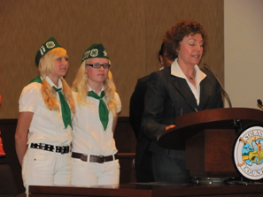

Newspaper Clipping

Diaper Round-Up Helps Solano County Families

The Issue
Transitional families, or families without income or homes, increased drastically during recent years. Many generous citizens have donated time and food to local food banks to provide for these families. However, not many people realize the great need for diapers for these transitional families.

What Has 4-H Done?
Two 4-Hers from Wolfskill 4-H Club, Hannah Crawford-Stewart and Kaylee Lindgren, realized the need for diaper donations and began the Diaper Round-Up, a county-wide community service project to benefit transitional families in Solano County. The first obstacle they hit was how to distribute these diapers - many food banks lack the capacity to store and distribute infants' diapers. After contacting ChildNet, Hannah and Kaylee set out to collect 1,000 diapers to donate to local families.

The Payoff
Local reporters soon picked up on the efforts of these two dedicated 4-Hers, and many community members became involved. Kaylee and Hannah collected nearly 3,000 diapers to donate to local families, and are continuing to collect diapers as long as there is a need. The girls were recognized by the Solano County Board of Supervisors for being activists in their community.
Letter w/ Picture

Author: Annalee Sanborn, Student Assistant, State 4-H Office

Sample Collection of Work (Continued)
VACA VALLEY 4-H RECORD BOOK WORKSHOP
Presented by: The Leadership Group

OPEN TO ALL MEMBERS!!!!
DATE: Monday, November 29
TIME: 7:00 pm
WHERE: 501 Texas Street
RSVP: NO LATER THAN November 26th
PHONE NUMBER: (707) 123-4567

Open to all members and their parents, but recommended for new members and their parents. Have any record book questions? Come and see if we have an answer for you.

If you have any questions call: Lyle Glass, Project Manager
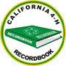
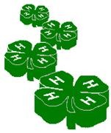
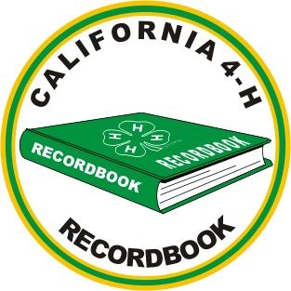
(707) 123-4567

4-H Flyer

Cavy Showmanship

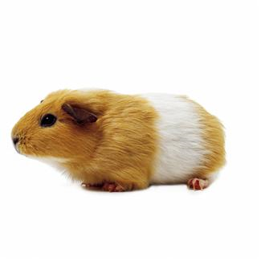
A basic guide to cavy showmanship

Katrina Castaneda
Sherwood Forest 4-H
Solano County
8/9/01 Emerald Star Project
Introduction
4-H Brochure

Cavy comes from the word cavia procellus, which is the scientific name for a guinea pig. They are called guinea pigs because in England, in the 1500’s they were old for a guinea or an old English coin. They were called guinea “pigs” because they squeal and grunt like pigs.

Why do Showmanship?
- To gain confidence and knowledge.
- To check for any disqualifications, faults or noticeable diseases.
- With this knowledge you can compete in showmanship events.

What cavy should you use?
- A calm cavy that you have worked and pratice with that can flip over on its back
- Your own healthy purebred cavy

What do you wear?
- Your 4-H Uniform if required by show or a long sleeve shirt to prevent scratches
What not to wear?
- Dangling objects-earrings, necklaces, bracelets, etc.
  - Colored nail polish

STEPS

Step 1
- Carrying and handling (5 points)
Step 2
- Introduction, appearance and action (10 points)
Step 3
- Checking the ears (6 points)
Step 4
- Checking the eyes (3 points)
Step 5
- Checking the teeth (3 points)
Step 6
- Checking the nose (3 points)
Step 7
- Checking the front feet and the hind feet (12 points)
Step 8
  - Checking the sex (6 points)
Step 9
  - Checking the coat (6 points)
Step 10
  - Viewing the cavy (8 points)
Step 11
  - The questions knowledge (10 points)
Step 12
  - Return cavy to cage (5 points)
Sample Questions
- What breed and variety is your cavy?
- Name 3 breeds of cavies.
- Name 3 varieties of cavies.
- Name 3 disqualifications.
- Name 3 faults.
- What is the most important Vitamin cavies need?
  - These are just sample questions the judge might ask. To really know your stuff and to find the answers to these questions look in the American Rabbit Breeders Assoc. (ARBA) Standard of Perfection and the ARBA Official Guide.

SAMPLE Picture Page
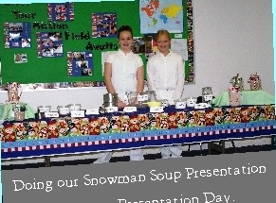
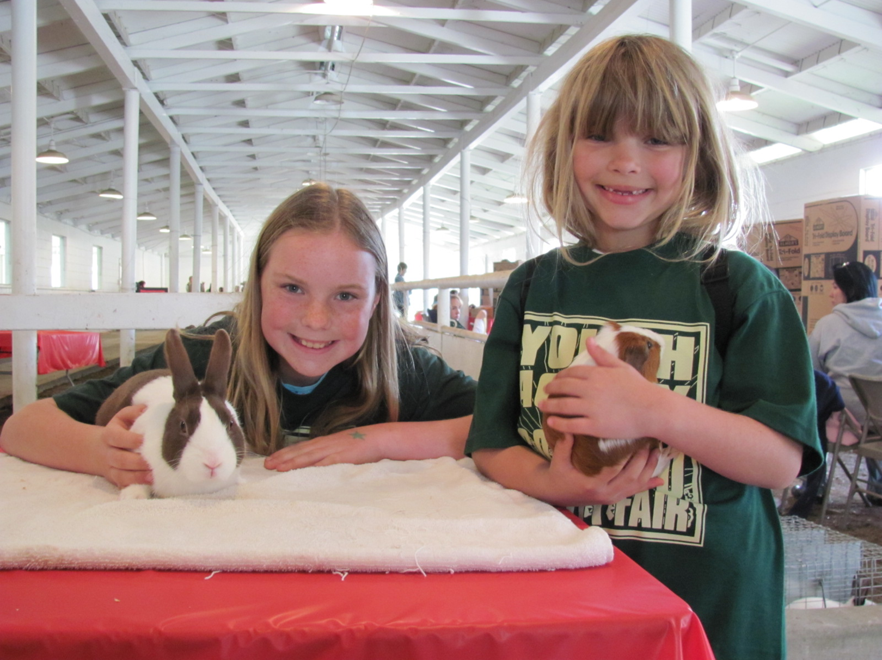
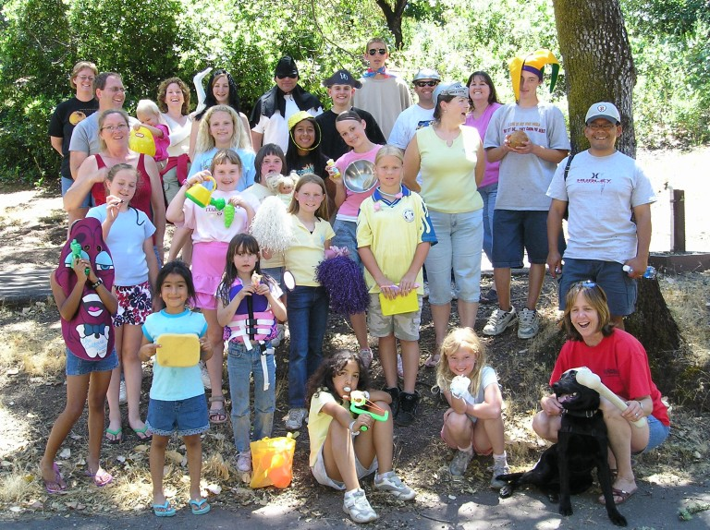
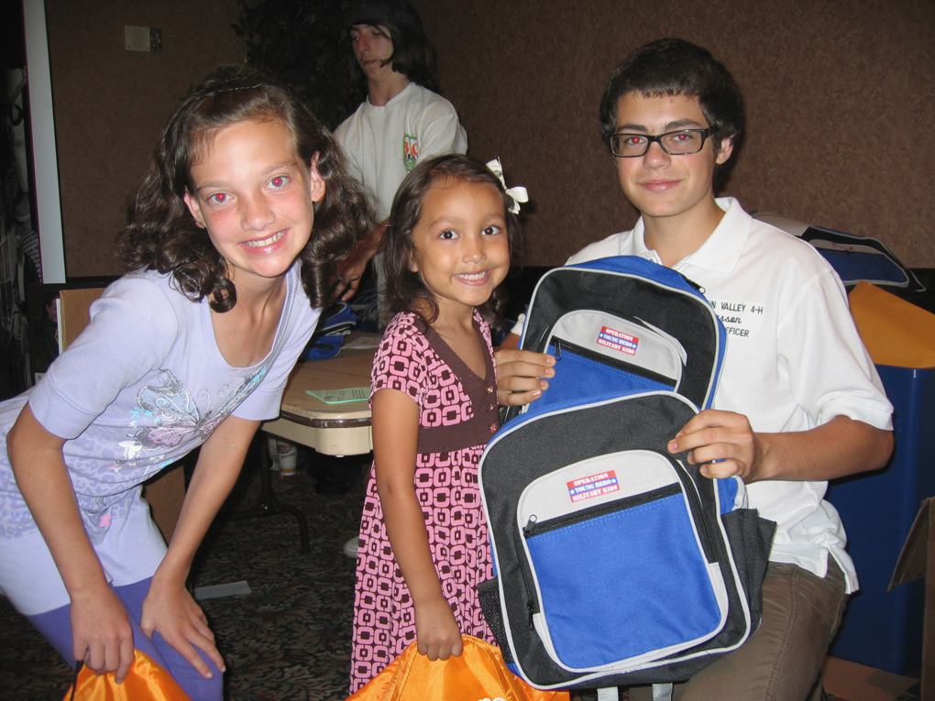
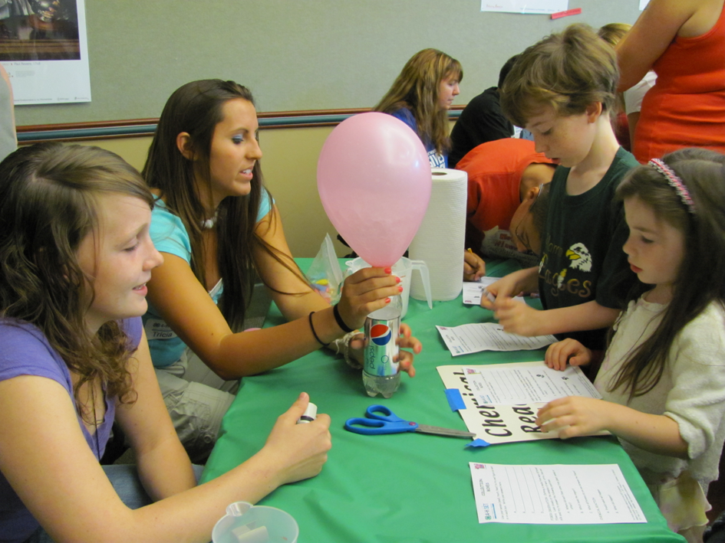
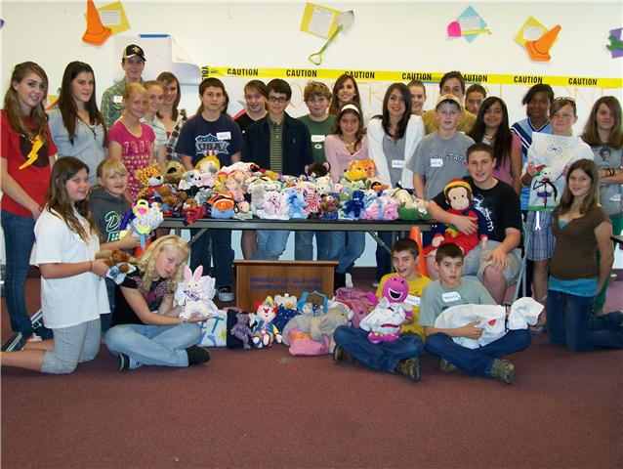
Westwind end of the year camping trip at the Russian River.
The “Sweet Dreams” community service project we did at the Solano County Leadership Retreat
Doing our Snowman Soup Presentation at County Presentation Day.
S.E.T. activities at Vacaville Town Square Library. Teens teaching youth about Science.
Ag Day 2010 at the Solano County Fairgrounds
Back Pack distribution at Travis Air Force Base with Carson Wignall, County All Star Ambassador.
California 4-H Record Book
4-H Science, Engineering and Technology (SET)
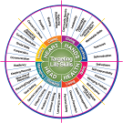
Abilities & Life Skills

4-H members may want to include specific science, engineering and technology (SET) abilities and life skills in their Annual Project Reports and 4-H Story. These SET Abilities focus on learning and doing science, engineering and technology. These are in addition to the Life Skills Wheel (developed by Iowa State University).

Is your 4-H project science, engineering or technology?
ALL projects use some SET abilities, even if the project is not listed as a science project.

Where should SET abilities be listed on the Annual Project Report?
4-H members can document these SET abilities in the “Learning Experiences” boxes on the first page. On the back of the form, members may specifically list things they made, raised, grew or improved.

4-H Science, Engineering and Technology Abilities
Observe | Draw / Design
Categorize/Order/Classify | Build/Construct
Organize | Collect Data
Infer | Invent/Implement Solutions
Question | Test
Predict | Research a Problem
Hypothesize | Interpret/Analyze/Reason
Evaluate | Troubleshoot
State a Problem | Redesign
Plan an investigation | Optimize
Use Tools | Collaborate
Develop Solutions | Compare
Design Solutions | Model/Graph/Use Numbers
Problem Solve | Summarize/Relate
Measure | Demonstrate/Communicate to Others

For more information
More information on the 4-H Science, Engineering and Technology (SET) Initiative is available at: http://www.ca4h.org/Projects/SET/



Suggested ABREVIATIONS

& | and
@ | at
comm. | Committee
Co. | County
CAL | Create a Leader Conference
DMFair, DMF | Dixon May Fair
ill. | Illustrated
I & R, I&R | Incentives and Recognition
Jr. | Junior
mtg. | meeting
mem./mbr | member
nat’l | national
proj. | project
rep. | representative
sect. | section
Sr. | Senior
SCFair, SCF | Solano County Fair
SLC | State Leadership Conference
wksh | workshop

IMPORTANT
THINGS TO REMEMBER

- Not everything can be counted or recorded on your Personal Development Form.
- You cannot add new material to your book after it has been judged.
- Corrections can only be made to the Personal Development Report entries that have already been recorded.
- Record things in chronological order. Next year's records will start the day after you turn in this year's record book.
- The Annual Project Report may not exceed 4 pages.
- Be NEAT! Make a sloppy copy on a photocopy form. Erase or neatly white out mistakes to correct. Use ink.
- Be sure to carry all totals on the Project Development Report over to Total This Year in the chart on page one. Complete ALL columns and sections that apply.
- Be sure to have ALL signatures on ALL forms.
- Be sure to complete an Annual Project Report Form for EACH project.
- Although it is optional, the Expression Page is your opportunity to show what you learned in your project in a more creative way!!!
- If competing beyond the club level inclusion of Expression and Collection of Work pages is strongly encouraged.
- Be sure to have ALL forms included in record book in the correct order.
- Don't include ribbons or project manuals.
- Use tab dividers to separate 4-H record years. Start with most current year in front and follow in order going backwards to the first year.
- Turn book in ON TIME.

- Keep all records from year to year in your record book. The exception is if you are submitting your record book for State Judging. Never throw any records away.

Keep better records NEXT YEAR!

HOW TO
IMPROVE
YOUR RECORD BOOK

Your record book should show growth from year to year. Record book judges will review your previous year's work to see if you have expanded your project. You might try adding more animals to your project or try a different skill or technique in your craft project. There is always more to learn in your project area. Judges will also look to see how active you are in your club and community. Showing leadership by giving presentations, teaching younger members, or serving as a club officer is important as well.

Here are some ideas to expand and improve your 4-H year:

- participate in club activities
- participate in county, sectional & state events and conferences
- give presentations
- give prepared talks at your club meeting (project reports)
- attend club & project meetings regularly
- be active in committees
- help younger members
- participate in citizenship/community service activities
- be a committee chair
- be a Jr./Teen leader
- serve as an officer

- attend field days & workshops
- make educational displays
- write and submit newspaper articles

Bringing
SERVICE LEARNING
to every project

“Service learning is an experiential process in which youth are involved in examining the needs within their own community and developing a project to help address those needs.”

Here are some community service ideas that could be developed into project service-learning opportunities:

- Drives: clothing, food, animal food for local S.P.C.A.

- Volunteer at local: soup kitchen, homeless shelter, food bank, recycling center, animal shelter, senior center, wildlife refuge, meals-on-wheels

- Recycle: aluminum cans, plastic, computer inkjet & laser cartridges, eye glasses, computers, cell phones

- Donate locally grown produce to: food bank, homeless shelter

- Read with others: local library, after-school program, boys & girls club, senior center, school reading event

- Support military troops: valentines for vets, write letters, collect supplies, make & send blankets

- Share your animal: senior center, homeless shelter, library, after-school program, boys & girls club, public venues

- Participate in: Relay for Life, charity walks, local “clean-ups”

- Plant a garden: boys & girls club, senior center, school, homeless shelter, city center

- Teach something you’ve learned from your project: youth, seniors

- Take photos for free: homeless shelter, public venue, boys & girls club, library event

- Adopt a: grandparent, highway, park, school
SHOWING GROWTH AND ADDING SIZE TO A 4-H STILL LIFE PROJECT

The importance of growth, size and scope can be difficult concepts for project members to understand, or sometimes even care about. Yet, these are the very things that an evaluator is looking for in a record book.

Most still life projects cover the following BASIC information:
learn how to use equipment
learn safety rules
learn how to read and follow directions
complete one or more items using the proper techniques
learn how to make exhibit ready for the fair
learn what the judges are looking for
learn how to select material for use in project

Growth can be shown each year by:
learning how to use new equipment
learning new techniques
using new materials that are more difficult to work with
completing more complex items that require more knowledge
making items independent of project meetings
keeping advanced records
showing creativity in planning & completing projects
involving the project in community service
exploring careers
becoming a good consumer and keeping records of such
giving presentations
participating in Projects Skills Day
participate in still life judging contests
making educational displays
helping younger members
becoming a Jr./Teen Leader
preparing and using teaching materials for a meeting
attending field days or workshops
giving project reports
combining with another project
planning special project day for county
hosting a Taste of 4-H

The member should show that he/she has gained new knowledge and skills each year. The size of the project doesn't necessarily mean that the member has been prolific in what was produced, as one item may be so advanced in techniques, materials, and time that there is only time for that one item to be completed.
SHOWING GROWTH & ADDING SIZE AND SCOPE
TO A 4-H LIVESTOCK PROJECT

The importance of growth, size and scope can be difficult concepts for project members to understand. These are dimensions that add new knowledge & skills, as well as interest, excitement, fun & creativity to a project. A member that continues in the same project for many years can easily get bored doing the same thing year after year. The list below offers ideas to expand the size and scope of a livestock project so that the member and his/her project can grow together.

Most livestock projects cover the following BASIC information:
selection of animal
safety
raise animals
learn to feed, house, exercise
learn body parts
learn about breeds
basic health
grooming for the fair/use of equipment
cuts of meats
auction, secure a buyer & write thank you notes

Growth can be shown, size & scope added by pursuing some of the ideas below. Members are not limited to only these suggestions.

Miscellaneous Activities
presentations
livestock judging
educational displays
project reports
helping younger members
Jr./Teen Leader
prepare and use teaching materials for a meeting
attend/participate/put on field days or workshops

Veterinary Care/Health
learn correct temperature/pulse/respiration, and how to take each
learn to identify a healthy animal
learn to identify a sick animal
learn diseases, symptoms, causes
effective treatments-oral, injections, topical
learn about diseases contagious to humans
how to worm
maintain health records
medications and how to use them properly
Marketing
where the livestock market is
differences between commercial livestock auctions and Jr. livestock auctions
determine a budget and needed selling price for a real or imaginary flock or herd
how market prices are determined and how to find out what they are
learn about meat inspection and grading
learn about brand inspection
reasons for animal and carcass condemnation
drug residues/withdrawal problems
visit auctions, feedlots, meat packing plants
learn the by-products of your species
learn about the livestock industry
promote your species or products from them
learn grading system used at fairs
understand yield grade and quality grade

Management
livestock identification
safety around animal and equipment
add a breeding project
learn about breeding practices
birthing preparation/procedures/complications
dock and/or castrate
assist or learn to shear wool
trim hooves
preparing and maintaining housing area
animal nutrition/digestion process
genetics
is the project self-supporting?
maintain management records
build reference library of livestock information
learn and use improved practices

Project Combinations
learn to spin wool/tan hides
learn to sew with wool or leather
learn to cook with products produced by your species
enroll in a Vet Science Project

Career Exploration
assisting a veterinarian
help on a ranch/dairy
learn butchering
work in a feed store or with a feed dealer
work at a fair in the livestock department
help at a kennel or animal shelter
Section 6: Previous Years’ Records

The following instructions are for Club and County: 4-H members include their previous year’s records at the back of the book, in reverse chronological order. All records are retained (including photographs).

STATE JUDGING ONLY

The following instructions are for State Judging only: Materials from all previous years in 4-H must be removed and replaced with a summary of your previous involvement in 4-H (the 4-H member may include all involvement as a 4-H member, including primary). These pages must be placed at the back of the 4-H Record Book and must conform to the standard formatting and page guidelines. Three pages are included. Many 4-H members use a bulleted list or table to summarize their previous experience, but any format is acceptable. If a bulleted list or table is used, please include items in reverse chronological order.

Include in your description for each of the three pages:
  - dates you were involved
  - role you played in the activity
  - size and scope of your project/activity
  - accomplishments, alone or working with others
  - designate level of participation with the appropriate letter:
  - I = Individual: independent, individual activity, not as part of a group.
  - L = Local club, unit, project, club/project committee
  - C = County, area/district, multi-club
  - M = Multi-county, section, or region
  - S = State
  - N = National, multi-state
  - G = Global, international, crossing U.S. boundaries

Page Maximum: Three (3) pages total for all three categories – One page to summarize projects, one page to summarize leadership development, and one page to summarize citizenship development.

Part A: Project Summary
On one sheet of paper, describe all of your 4-H project work and project learning experiences throughout your years in 4-H. Show examples of how your project meets the following:
- Participation in 4-H learning experiences such as demonstrations, talks, exhibits, judging events, field trips, tours, workshops, conferences and camps attended, and activities where you taught others.
- Knowledge and skills gained from working on the 4-H projects or activities. Review your total time in this program; consider goals you have had, and summarize the knowledge and skills gained.
- Size and scope of your 4-H projects or activities. Size means anything that can be expressed in quantity. Select examples that show your growth through 4-H participation. Scope refers to range of operation and growth, over time. Use numbers carefully to show size and depth of growth within this program.

Part B: Leadership Summary
On one sheet of paper, describe all of your 4-H leadership experiences and other significant leadership experiences you have had outside of 4-H, in school or community organizations throughout your total years in 4-H. Show examples of how you have:
- Collaborated with others and served as a role model for other members.
- Identified and understood roles, attitudes, and tasks necessary for effective leadership.
- Worked in a youth-adult partnership.
- Worked as a member of a team at club, county, regional, state and national levels.
- Assumed responsibility for program planning and implementation.
- Served as a Junior or Teen Leader for 4-H projects.

Part C: Citizenship Summary
On one sheet of paper, describe 4-H citizenship and service-learning experiences you have had in
4-H and community organizations throughout your total years in 4-H. Citizenship is defined as acting with informed concern for self and others as an individual or group action. Service-Learning has been defined as a type of experiential education (hands-on) that involves young people in both community service and education. Show examples of how you have:
- Been involved in the planning and action on specific community improvement projects.
- Collaborated with other community resources to identify and develop programs.
- Demonstrated social responsibility.
- How your community has benefited or been improved.
- How you have worked cooperatively with other community programs or agencies.
- What you have learned about the global community.

“Strive for excellence, not perfection.” ~ H. Jackson Brown Jr.
Evaluation and Competition

Since the early 1900’s, 4-H Record Book competition has been judged annually. Initially, competitions focused on project skill development, primarily in agricultural areas. Now, 4-H Record Book competitions measure members leadership development, citizenship activities and personal growth as well as project proficiency. 4-H Record Books may be judged at the club, county and state levels. There is no national judging.

The Purpose of Record Book Competitions:
- Provides an incentive to members to record their project work and personal achievement in their 4-H Record Book.
- Members receive feedback and encouragement on their 4-H project skill development, leadership and citizenship development, and record-keeping skills.
- Members are recognized for outstanding 4-H work.

Levels of Competition

Club Level
4-H Record Books are first reviewed at the local level by 4-H Community Club Leaders and Project Leaders. Club level judging is based on the Danish system where 4-H Record Books are judged against a standard. Seals are awarded based on the member’s 4-H project work, personal growth and the book’s organization. Through their personal achievements and 4-H participation, members may earn Star Rank recognition.

County Level
Members may submit their 4-H Record Books for county competition. Books are judged on the member’s 4-H work, leadership and citizenship development, and personal growth. County level judging should be based on the Danish system with all books judged against a standard. Judges provide a critique and suggestions for future growth and involvement. Counties may designate awards for 4-H Record Books in specific project categories and age groups based on meeting published standards.

State Judging

Senior 4-H members are eligible to enter state competition. State level competition is focused on recognizing 4-H members who have outstanding 4-H Record Books. Forms, additional instructions, and specific age eligibility may be found at http://www.ca4h.org/Resources/Members/RecordBook/RBCompetition

Please Note: Modifications made to the forms, formatting or requirements outlined in this manual or omissions by the member, club or county are reasons for disqualification. All supplemental and club/county specific forms must be removed.

4-H Record Book Resources

Download Solano County 4-H Record Book Forms at:
http://cesolano.ucdavis.edu/4-H_Program/Record_Books

Solano County Personal Development Report Support Piece:

http://cesolano.ucdavis.edu/4-H_Program/Record_Books/Solano_County_Personal_Development_Report_Support_Piece/

4-H Youth Development Resources

Essential Elements of Youth Development
http://www.ca4h.org/About/Mission/PYD/

Questions and comments can be directed to:
4-H Incentives and Recognition Committee
California 4-H Youth Development Program
University of California
501 Texas Street, 1st Floor
Fairfield, CA 94533


The University of California prohibits discrimination or harassment of any person on the basis of race, color, national origin, religion, sex, gender identity, pregnancy (including childbirth, and medical conditions related to pregnancy or childbirth), physical or mental disability, medical condition (cancer-related or genetic characteristics), ancestry, marital status, age, sexual orientation, citizenship, or status as a covered veteran (covered veterans are special disabled veterans, recently separated veterans, Vietnam era veterans, or any other veterans who served on active duty during a war or in a campaign or expedition for which a campaign badge has been authorized) in any of its programs or activities.

University policy is intended to be consistent with the provisions of applicable State and Federal laws.

Inquiries regarding the University’s nondiscrimination policies may be directed to the Affirmative Action/Equal Opportunity Director, University of California, Agriculture and Natural Resources, 1111 Franklin St., 6th Floor, Oakland, CA 94607, (510) 987-0096.

Formatting instructions: 4-H story must be on 8 ½” by 11” plain white regular paper. Single sided, single or double spaced, 1 ½” inside (left) margin and 1” top, bottom, and outside margins. If typed, font size must be 12 point in Arial, Garamond, Helvetica or Times New Roman.

